Welcome to the August edition of Prayer Matters. We’ve got something a bit different for you this month, and we hope it will provide you with some enriching moments of prayer in these summer days.
Prayer Matters exists to help us pray for the mission and ministry of The Salvation Army in a united and effective way. We use a prayer rhythm to help us make sure we’re praying for every aspect of Salvation Army life, and that rhythm is based around seven different themes, one theme for each day of the week:
- Monday – Sharing the Good News
- Tuesday – Serving and Caring
- Wednesday – Justice and Reconciliation
- Thursday – International Salvation Army
- Friday – Growing in Faith
- Saturday – Care for Creation
- Sunday – Sabbath Prayer
The themes are pretty broad, so each day we give a more specific subject or situation to pray for, which fits somewhere in that broad theme. But this month we thought we might pray through those themes in a slightly different way. Instead of giving you a prayer request for each day, we’re inviting you to join us in reflecting on the themes themselves. What does it mean for The Salvation Army to share good news, for instance, or to serve and care for people without discrimination; to seek justice and reconciliation, to care for creation and to nurture disciples as they grow in their faith? We’re going to offer you some words, images and music, and we invite you to make time each day to pray and reflect on the suggestion for that day, rather than just pinging off a quick prayer in the midst of the busyness.
Five out of our seven daily themes form the priorities for The Salvation Army’s Mission Statement here in the UK and Ireland. We also join The Salvation Army International on a Thursday to pray for other territories; and on Sunday we have a Sabbath Prayer focus.
As we pray together this month, let’s allow these themes to challenge and encourage us more deeply than ever, and let’s ask God to speak to us through them.

Lyndall Bywater and the UKI Boiler Room Team

MONDAY: SHARING THE GOOD NEWS
At the heart of The Salvation Army’s mission is a passion to proclaim the good news of Jesus Christ. This is not an optional extra. The Salvation Army only does what it does because our inspiration and vision come from people’s ongoing relationship with Jesus. We know the difference our relationship with God makes in our lives and we don’t want anyone to miss out.

TUESDAY: SERVING AND CARING
The Salvation Army responds to people without discrimination. God calls us to be with the people we serve. In ‘being with’ people – as against ‘doing for’ people – we find solutions and make progress because we are all made in the image of God. We are called to share love in a too often loveless world. Jesus himself called us to love God and love others.

WEDNESDAY: JUSTICE AND RECONCILIATION
God longs for justice for all people. Therefore The Salvation Army will speak out against injustice. We fight not simply the effects of injustice but also the systems and structures that create and enable injustice. Seeking reconciliation is also an essential part of Salvation Army life. Justice and reconciliation are vital activities to achieving ‘Our Vision’ of ‘fullness of life for all with Jesus’.

THURSDAY: INTERNATIONAL SALVATION ARMY
The Salvation Army is a church embracing the world with the love of Jesus; transforming communities in 134 countries; sharing the life-giving Spirit of God across all generations. Each week, Salvationists around the world unite in praying for the same territory or region of The Salvation Army.
https://www.salvationarmy.org/prayer-focus

FRIDAY: GROWING IN FAITH
The future of The Salvation Army depends on nurturing Christians who, filled with the Holy Spirit, can share the good news of Jesus. Like an athlete, Christian disciples need to stay ‘spiritually fit’ by practising disciplines such as prayer, Bible reading, participating in corporate worship, tithing and helping others. The Salvation Army believes being a disciple of Jesus and seeking holy living is the way to experience ‘fullness of life’.

SATURDAY: CARING FOR CREATION
The Salvation Army is committed to helping change attitudes, resulting in a more responsible use of our planet. We seek to provide practical care and advocacy for people affected by damage to the environment. People will not experience fullness of life unless God’s creation is protected and cared for.

SUNDAY: SABBATH PRAYER
‘Sabbath is not primarily about us or how it benefits us; it is about God, and how God forms us. It is not, in the first place, about what we do or don’t do; it is about God – completing and resting and blessing and sanctifying. These are all things that we don’t know much about … But it does mean stopping and being quiet long enough to see – open-mouthed – with wonder – resurrection wonder … we cultivate the ‘fear of the Lord’. Our souls are formed by what we cannot work up or take charge of. We respond and enter into what the resurrection of Jesus continues to do.’
(Christ Plays in Ten Thousand Places: A Conversation in Spiritual Theology by Eugene Peterson)

The outlines of the five Mission Priorities can be found at https://www.salvationist.org.uk/faith/our-vision-and-mission

SATURDAY 1 August: CARING FOR CREATION
The Salvation Army believes that protecting and caring for God’s creation is a vital part of people experiencing fullness of life.
Ask the Holy Spirit to speak as you listen to these two songs:
‘This is My Father's World’ – Keith & Kristyn Getty www.youtube.com/watch?v=NwqTvmpnKeE
‘The Lost Words Blessing’ – Spell Songs www.youtube.com/watch?v=Hg1xFYpXuWA
(Lyrics at thebirdsings.com/lost-words-blessing/)

SUNDAY 2 August: SABBATH PRAYER
Use the quote and art below to reflect on how God forms us and what it means to participate with and for God on Sabbath.
‘Sabbath is not primarily about us or how it benefits us; it is about God, and how God forms us.’ (Working the Angles: The Shape of Pastoral Integrity by Eugene Peterson)

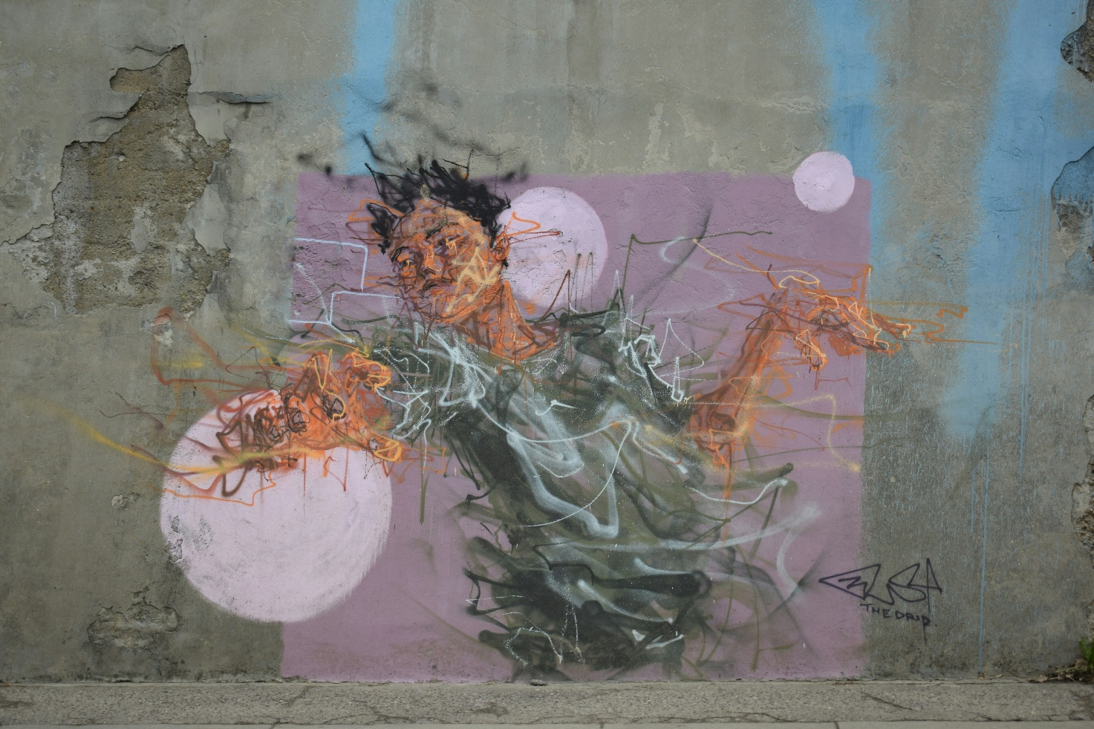
Zaric, M. (2019). Mural Concrete Wall [Photograph]. Unsplash. unsplash.com

MONDAY 3 August: SHARING THE GOOD NEWS
‘But we have this treasure in clay jars, so that it may be clear that this extraordinary power belongs to God and does not come from us.’ (2 Corinthians 4:7, NRSV)
Reflection: If you’ve ever heard a child telling you about their favourite birthday present, you’ll know that good news always sounds best when the person passing it on to you is already wowed by it. If you were to analyse your motives for talking to others about Jesus, would joy or guilt come out strongest? Do you tell them because you feel you should, or because it bubbles up in you in an unstoppable way?
To be effective sharers of the good news, we need to be wowed by it ourselves. Perhaps it’s old news to us – we heard the stories of Jesus when we were tiny and they no longer surprise us. Or perhaps it’s the fear of people asking questions we can’t answer.
What might it feel like for you to connect afresh with the good news of Jesus in your own life? Are there areas where you have disqualified yourself from being made whole and set free? What gift or work of God in your life are you most grateful for? Why not find someone to share it with.

TUESDAY 4 August: SERVING AND CARING
The Salvation Army responds to people without discrimination. We are called to share love in a too often loveless world.
God, you are the source of all love. Forgive us when we edit or limit your love because of our own prejudice. Grow our hearts when love feels too difficult. Renew in us your unconditional, unending love, that we might walk others home to the warmth of your embrace.

WEDNESDAY 5 August: JUSTICE AND RECONCILIATION
For The Salvation Army, justice and reconciliation are vital activities to achieving our vision of ‘fullness of life for all with Jesus’.
Prayer activity: Begin a collage or scrap-book journal to help you pray for people who live with the daily realities of injustice. You could use images, cuttings, textures or colours, and you might like to build it up over time. It’s important to make it a physical thing, rather than something you can file away in your phone, as that will help to keep those people present in your heart and mind.

THURSDAY 6 August: INTERNATIONAL SALVATION ARMY
The vision statement for the Brazil Territory is ‘A holy people engaged in the mission, who work in unity and passionately as agents of transformation in Brazilian society’. As you spend some time reflecting on the image below, observe the contours of the landscape and the everyday life that fills the buildings and streets. As you reflect, pray for God to continue to shape his people in the Brazil Territory that they may see his transformation in the spiritual landscape around them and be refreshed by his Spirit.

Dias, D. (2018). City Building by Body of Water [Photograph]. Unsplash. unsplash.com

FRIDAY 7 August: GROWING IN FAITH
The Salvation Army believes being a disciple of Jesus and seeking holy living is the way to experience ‘fullness of life’.
Music: Listen to these songs and go where the Spirit leads you.
‘Burning, Burning’ by John Gowans and John Larsson performed by Lauren and Karl Westwood
www.youtube.com/watch?v=bDNvodnQGMA
‘The Power of Your Love’ by Geoff Bullock performed by Hillsong
www.youtube.com/watch?v=H9_0jiO5ZRM

SATURDAY 8 August: CARING FOR CREATION
‘Happy are those whose help is the God of Jacob, whose hope is in the Lord their God, who made heaven and earth, the sea, and all that is in them; who keeps faith for ever …’ (Psalm 146:5-6, NRSV)
Reflection: Care for creation has become a major focus for many churches and denominations over the past decade or so. For some it has been a ‘difficult sell’, so to speak, because of the prevalence of theologies which suggest that the Earth is scheduled for destruction anyway, so why worry about caring for it. In other church settings, it’s more a matter of ‘spiritual things’ being seen as more important than physical things.
Have we in The Salvation Army perhaps been given something of a head start? We are formed in a tradition where the physical matters: people’s bodies and their physical needs; the material considerations of where people will live, what they will do for work or how they will bring justice in their own communities. For William Booth, salvation stood alongside soup and soap.
If we hear the call to fight … to fight for the hungry, the enslaved and the imprisoned, might we also find the fervour to fight for the rest of God’s creation?
Could you write a couple of lines in the style of William Booth’s reported ‘I’ll Fight’ speech, expressing the same determination about fighting for the planet as he demonstrates when he talks about fighting for the people who live on it?
Read more about William Booth’s speech here:
salvationist.ca/articles/a-new-rallying-cry/

SUNDAY 9 August: SABBATH PRAYER
‘It (Sabbath) is not, in the first place, about what we do or don’t do; it is about God – completing and resting and blessing and sanctifying.’ (Living the Resurrection: The Risen Christ in Everyday Life by Eugene Peterson)
Prayer: Lord, on this Sabbath day, I welcome your completing; finish in me the work you have been doing this week. I welcome your rest; help me to lay down my burdens. I welcome your blessing; help me make room for the treasures which can only be given in space and stillness. I welcome your sanctifying; re-create me for the sake of your glory.

MONDAY 10 August: SHARING THE GOOD NEWS
At the heart of The Salvation Army’s mission is a passion to proclaim the good news of Jesus Christ. This is not an optional extra.
Prayer activity: Take some time to look at the week ahead. Open your diary or calendar, or just picture the things you’ll be doing and the people you’ll be seeing. As you call each event or task to mind, pause to think about what it might mean to proclaim the good news of Jesus Christ in that situation. Then give that thought back to God as a prayer.

TUESDAY 11 August: SERVING AND CARING
Reflect on the image below, asking God to speak to you on what it means to serve and care in the landscape around you. Ask God for wisdom and discernment to see where people need support, and ask God to equip you with strength and resource. Take some time to consider God’s passionate love and care for you personally, allowing God to serve you in his goodness and abundance.

Thomas. N. (2017). When You Need a Helping Hand [Photograph]. Unsplash. unsplash.com

WEDNESDAY 12 August: JUSTICE AND RECONCILIATION
‘Is not this the kind of fasting I have chosen: to loose the chains of injustice and untie the cords of the yoke, to set the oppressed free and break every yoke?’ (Isaiah 58:6, NIV)
Reflection: There’s an old adage that talks about the futility of keeping on rescuing people who’ve fallen into a river if you don’t at some point take time to work out why they’re falling into that river in the first place. Find the root of the problem and you can do far more good.
What might it look like for The Salvation Army to tackle injustice at source, as well as helping those who have already begun to get swept away by it? How might The Salvation Army be even more of a positive force for social cohesion in the UK and Ireland than it already is?
We have several teams who speak into issues of public policy at a national level; but what might The Salvation Army do locally, where you are, to disrupt the systems which cause injustice in the first place?

THURSDAY 13 August: INTERNATIONAL SALVATION ARMY
Today, the worldwide Salvation Army is praying for the Sweden and Latvia Territory, a territory famous for its musical heritage, which includes the gospel choir VasaGospel, a vibrant group of musicians who love to share their faith through music.
Music: We invite you to hold the Salvationists of Sweden and Latvia before God as you listen to these two songs from VasaGospel.
‘Great I am’ – Vasa Gospel feat. Ashley Haynes & Jermaine Harris
www.youtube.com/watch?v=FbGdRyDUfiE
‘Brighter Day’ – Vasa Gospel
www.youtube.com/watch?v=8molr1UGOwU

FRIDAY 14 August: GROWING IN FAITH
In John 4:13,14 Jesus describes the living water of the Spirit to a Samaritan woman at a well. ‘Jesus answered, “Everyone who drinks this water will be thirsty again, but whoever drinks the water I give them will never thirst. Indeed, the water I give them will become in them a spring of water welling up to eternal life.”’ This living water of the Spirit is a wonderful promise of refreshment, depth, movement and growth.
Seeds are regarded as botanical marvels. They are tiny, self-contained survival capsules, some of which can suspend their own growth for decades. However, as soon as they absorb water their stored energy has the potential to create an explosive whirlwind of growth. Recently it was reported that a 32,000-year-old ice age seed was successfully revived and has now grown its very own seeds! Take some time to marvel at the wonders of God’s Spirit which brings us life in all its fullness, much like the seed. Ask God to help you absorb his living water and release new growth.

Glenn, K. (2017). Trees During Daytime [Photograph]. Unsplash. Unsplash.com

SATURDAY 15 August: CARING FOR CREATION
The Salvation Army is committed to helping change attitudes, resulting in a more responsible use of our planet. We seek to provide practical care and advocacy for people affected by damage to the environment.
Prayer: Creator God, when it comes to caring for creation, sometimes the challenge to change attitudes feels like an uphill struggle, particularly when people seem stretched and overloaded by so much else in life. Help us to live out our commitment to caring for our planet. Make us effective advocates, not with judgemental guilt-trips but with infectious joy. May that joy soften hearts and change minds.

SUNDAY 16 August: SABBATH PRAYER
‘Our souls are formed by what we cannot work up or take charge of. We respond and enter into what the resurrection of Jesus continues to do.’ (Eugene Peterson)
Music: As you listen to these pieces, let the resurrection life of Jesus fill you again.
‘Mid all the traffic’ – Regent Hall Band
www.youtube.com/watch?v=Ps6OwAq8xq4
‘Share my yoke’ – International Staff Songsters
www.youtube.com/watch?v=jOISuYrBtmE

MONDAY 17 August: SHARING THE GOOD NEWS
Jesus often spoke about a life of God filled with abundance. Using the image below, imagine bringing your heart as a cup to God and spend time allowing him to fill it. Ask God to use his abundance in your life with others. It can be easy to talk ourselves out of being generous with our words or sharing who God is conversation. If you feel those moments arising when you’re with others, picture the cup of your heart bubbling over and know the God of abundance invites us to share freely just as he does with us.

Schiereck, M. (2019). Greyscale Water Pouring [Photograph]. Unsplash. unsplash.com

TUESDAY 18 August: SERVING AND CARING
‘Is not this the kind of fasting I have chosen: … Is it not to share your food with the hungry and to provide the poor wanderer with shelter – when you see the naked, to clothe them, and not to turn away from your own flesh and blood?’ (Isaiah 58:6,7, NIV)
Reflection: What do we do when there’s not enough to go around? We’re living through a cost of living crisis at the moment. Things are getting more expensive and we’re having to think twice, maybe even three times, about how to use our resources wisely. Perhaps that’s when we start to draw lines – lines between the deserving and the undeserving.
Short of praying for miracles (a good idea of course), there’s not much we can do about the limitations of our financial resources. In these more challenging times, some people might not get as much as they need. But how can we guard against dividing people into deserving and undeserving? What can we do to ensure that our care for others remains willing, generous and unprejudiced?

WEDNESDAY 19 August: JUSTICE AND RECONCILIATION
God longs for justice for all people. Therefore The Salvation Army will speak out against injustice. We fight not simply the effects of injustice but also the systems and structures that create and enable injustice.
Music: Let these songs stir a deeper longing for justice in your heart.
‘Faithful (They Need Christ)’ – transMission
www.youtube.com/watch?v=F0UuPKQ1-3Y
‘Don’t Tell Them Jesus Loves Them…’ – Steve Camp
www.youtube.com/watch?v=LDf3S7fKb2I
Lyrics at genius.com/Steve-camp-dont-tell-them-jesus-loves-them-lyrics

THURSDAY 20 August: INTERNATIONAL SALVATION ARMY
Today, the worldwide Salvation Army is praying for the India South Eastern Territory.
Prayer activity: To better understand the challenges which the Army in South-east India faces, why not do an internet search to find out some of the most recent news stories from that part of the world. Then reflect on how those events might affect Salvationists there.

FRIDAY 21 August: GROWING IN FAITH
‘And I pray that you, being rooted and established in love, may have power, together with all the Lord’s holy people, to grasp how wide and long and high and deep is the love of Christ, and to know this love that surpasses knowledge – that you may be filled to the measure of all the fullness of God.’ (Ephesians 3:17-19, NIV)
Reflections: Kew Gardens maintains the Millennium Seed Bank at Wakehurst Place, which is an archive containing over 2.4 billion seeds taken from all sorts of trees and plants over many decades. The most astonishing thing about some of these seeds, which are years, even decades old, is that if you planted them in the right conditions, they could still grow into something.
Growing is such a vital and natural part of God’s creation that it will happen in the most remarkably unlikely of circumstances. We may feel as though growing as a disciple requires a vast amount of effort and discipline on our part, but that’s not true. Discipline is a great quality to cultivate, but the moment we allow God to plant us in the soil of love, we begin to grow. Things change in us; the impossible becomes possible. Our roots go down, our branches reach wide and our lives bear fruit.
Do you need to put yourself in the hands of the Gardener again today?

SATURDAY 22 August: CARING FOR CREATION
‘Even a wounded world is feeding us. Even a wounded world holds us, giving us moments of wonder and joy. I choose joy over despair. Not because I have my head in the sand, but because joy is what the earth gives me daily and I must return the gift.’ (Braiding Sweetgrass: Indigenous Wisdom, Scientific Knowledge, and the Teachings of Plants by Robin Wall Kimmerer.
Using this quote and the image below, spend some time choosing joy over our world which still blooms in woundedness.
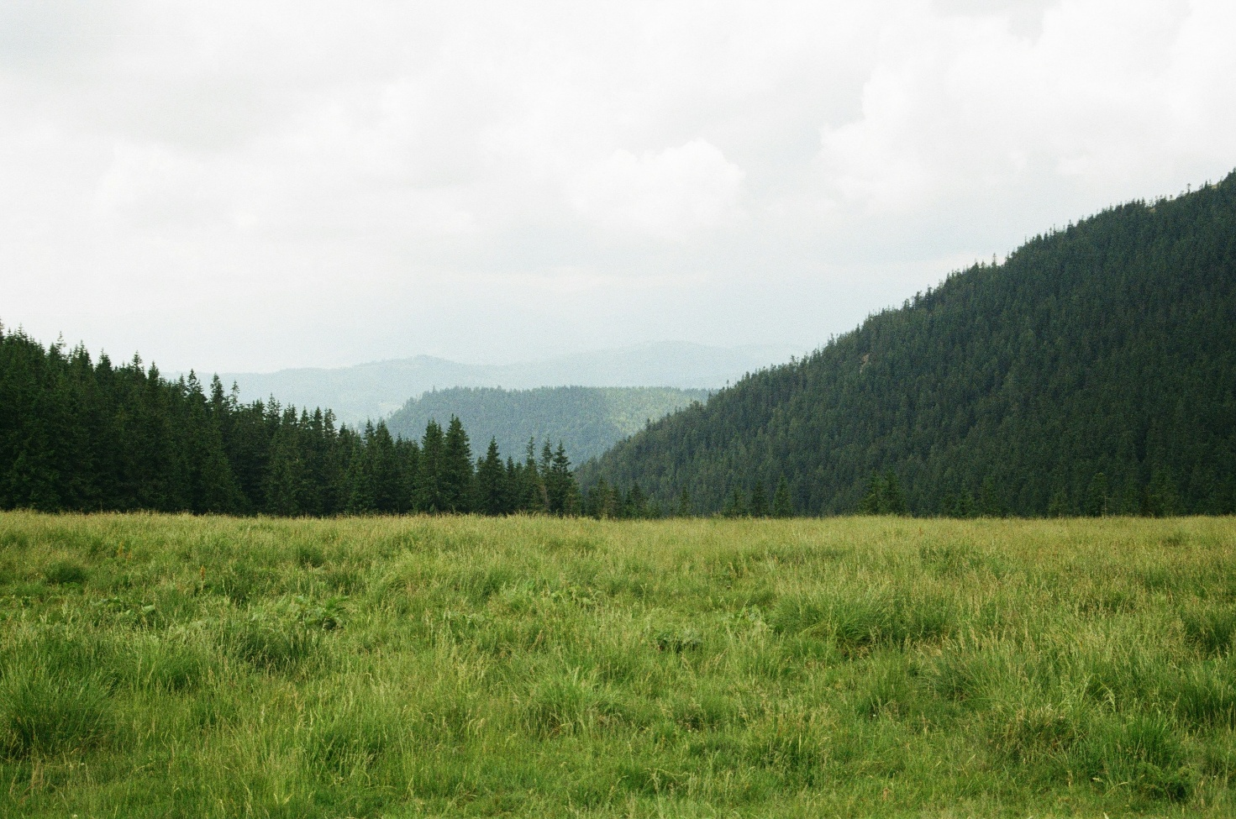
Rastvorova, K. (2019). Mountain Covered with Green Leafed Trees [Photograph]. Unsplash. unsplash.com

SUNDAY 23 August: SABBATH PRAYER
‘It (Sabbath) is about God – completing and resting and blessing and sanctifying. These are all things that we don’t know much about …. But it does mean stopping and being quiet long enough to see – open-mouthed – with wonder – resurrection wonder …’ (Eugene Peterson)
Prayer activity: Wonder is one of those things that revives us. Awe is good for our souls. The wow factor reconnects us with the presence of the divine. Who or what brings you wonder? How can you include that person/place/activity in your day today?

MONDAY 24 August: SHARING THE GOOD NEWS
The Salvation Army only does what it does because our inspiration and vision come from people’s ongoing relationship with Jesus. We know the difference our relationship with God makes in our lives and we don’t want anyone to miss out.
Prayer: Jesus Christ, you came to save us and to set us free. Forgive us when we live in only the tiniest corner of that truth; when we believe just enough of it to get by; when we don’t absorb the full wonder of it. Forgive us too when we’re not excited enough about it to share it. Help us to be a Salvation Army which is unapologetically exuberant about the good news of your saving love. Set us free, we pray.

TUESDAY 25 August: SERVING AND CARING
God calls us to be with the people we serve. In ‘being with’ people – as against ‘doing for’ people – we find solutions and make progress because we are all made in the image of God.
Video: As you listen to the music and watch the video footage of The Salvation Army serving and caring, take a moment to thank God for all that is happening around the UK and Ireland Territory.
The Salvation Army’s work throughout the UK and Ireland, set to the song ‘Serve by Love’ by Janet Robson and Richard Phillips.
www.youtube.com/watch?v=l1G3gUkUiu0

WEDNESDAY 26 August: JUSTICE AND RECONCILIATION
Contemplate the image below, and ask God to bring to mind people who have been silenced by injustice. Allow some time of silence, and then spend a few minutes praying aloud using your own voice as spiritual act of standing up to injustice.
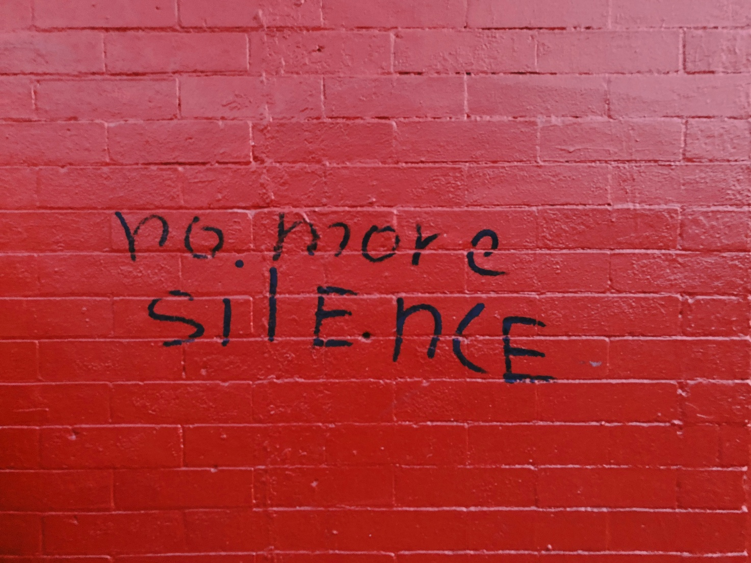
Tyson, J. (2018). Red Concrete Wall [Photograph]. Unsplash. unsplash.com

THURSDAY 27 August: INTERNATIONAL SALVATION ARMY
Reflection: Some words from General Lyndon Buckingham to reflect on today, as we pray for the International Salvation Army.
‘I appeal to you, in this universal call upon The Salvation Army, that we pray for the Holy Spirit to inject us with a divine sense of urgency about our missional and spiritual life … Bronwyn and I know and sense with every fibre of our beings that we need spiritual breakthrough which will see our faith communities in every place leaving behind the experience and language of declining numbers and living into health and growth and a flourishing that will continue long into the future.’
www.salvationarmy.org/resources/generals-global-call-action

FRIDAY 28 August: GROWING IN FAITH
Like an athlete, Christian disciples need to stay ‘spiritually fit’ by practising disciplines such as prayer, Bible reading, participating in corporate worship, tithing and helping others.
Prayer: God of abundant life, you have loved us, so we have come home to you. You turn your face towards us and we flourish in the kindness of your gaze. You shine on us and we grow in you. Grateful for your grace, we also recognise the challenge to stretch ourselves; to soak up the life you pour into us and to metabolise it into transformation. Help us build the habits that will take us further and deeper in you.

SATURDAY 29 August: CARING FOR CREATION
The Salvation Army is committed to helping change attitudes, resulting in a more responsible use of our planet.
Prayer activity: Go for a walk around the area where you live. Ask God to help you notice signs of life – those places where animal and plant life is thriving and where creation is at work. Stop and pray blessing in those places, giving thanks for the life you see, but also praying for growth and flourishing in the lives of the people who live around you.

SUNDAY 30 August: SABBATH PRAYER
‘Come to me, all you who are weary and burdened, and I will give you rest. Take my yoke upon you and learn from me, for I am gentle and humble in heart, and you will find rest for your souls. For my yoke is easy and my burden is light.’ (Matthew 11:28-30, NIV)
Reflection: What’s the difference between a day off and a Sabbath? Perhaps it’s that a day off is a day when we take a break from the things which occupy us for the rest of the week, whereas, from the way Jesus speaks to his disciples in this passage in Matthew’s Gospel, a Sabbath is something of a reset. It’s not just about pressing pause on the tasks to give ourselves a bit of a breather. It’s giving God space to upload in us a completely different ‘operating system’, one which helps us remain in the rest and the lightness which Jesus promises.
What could you do to make today less of a day off and more of a Sabbath?

MONDAY 31 August: SHARING THE GOOD NEWS
The Salvation Army only does what it does because our inspiration and vision come from people’s ongoing relationship with Jesus. We know the difference our relationship with God makes in our lives and we don’t want anyone to miss out.
Music: Listen to these songs and see where the Spirit takes you, as you ponder how The Salvation Army might share the good news of Jesus.
‘I Dare to be Different’ – International Staff Songsters
www.youtube.com/watch?v=bMhz0NulaR4
‘Build your Kingdom Here’ – Rend Collective
www.youtube.com/watch?v=sbdJXKqVgtg

