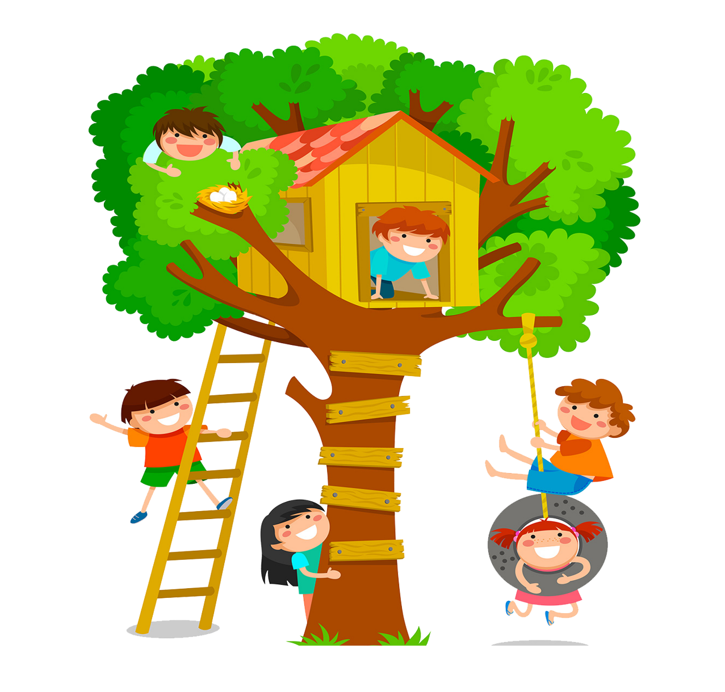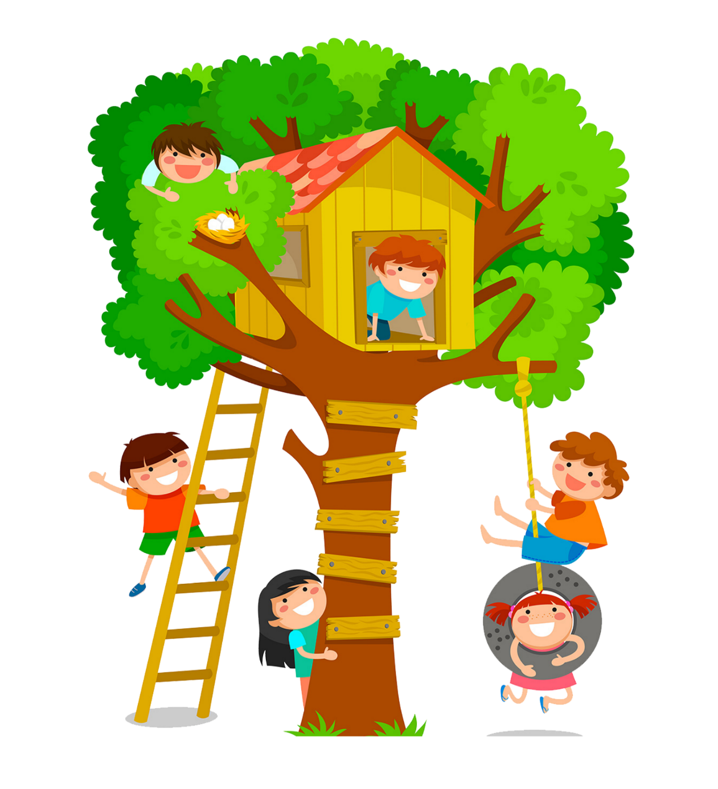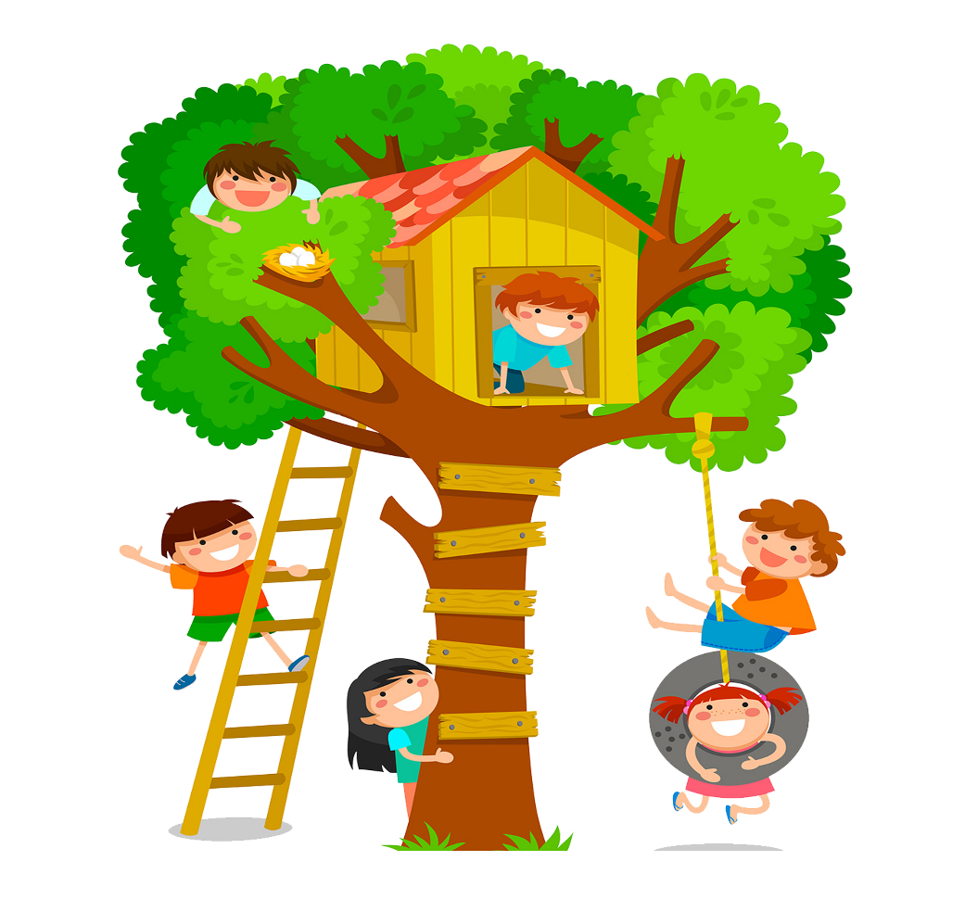 **GE T**

**OUTSIDE WITH TODDLERS**

**GET OWT!**

****Insert corps name*****

**The Salvation Army is a Christian Church and registered charity**

**England and Wales (14779) Scotland (SC009359) Republic of Ireland (CHY6399).**

LET NATURE NURTURE YOUR LITTLE ONES

OUTDOOR ACTIVITIES

Have fun… play & discover!

INSERT DAY

****am – ****pm



LET NATURE NURTURE YOUR LITTLE ONES

GO WILD, Explore, play, & discover WITH FUN OUTDOOR ACTIVITIES