TOGETHER22

ACCESSIBILITY GUIDE
Saturday 16 July to Sunday 17 2022

We are committed to making Together22 an enjoyable experience for everyone. This guide contains information about the facilities and support that will be available during the event.

Venue

International Convention Centre (ICC),
8 Centenary Square,
Birmingham,
B1 2EA.

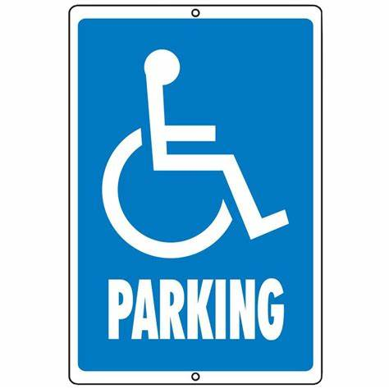
Disabled

Blue Badge Parking

Location
Blue Badge parking spaces are at the Utilitia Arena,
Kings Edward Road,
Birmingham,
B1 2AA.
This is a short walking distance from the ICC Birmingham.

Booking
Six disabled parking spaces are available which need to be booked in advance on the following website: https://www.utilitaarenabham.co.uk/your-visit/parking/
Quote ICC location code 5020 when booking.

Please note that additional disabled parking spaces are available on other wings of the Utilitia arena but also need to be booked in advance.

Walkway
There is an accessible walkway from the Car Park to the ICC Birmingham via Brindley Place.

There is a lift from Brindley Place to the bridge leading to the ICC Birmingham.

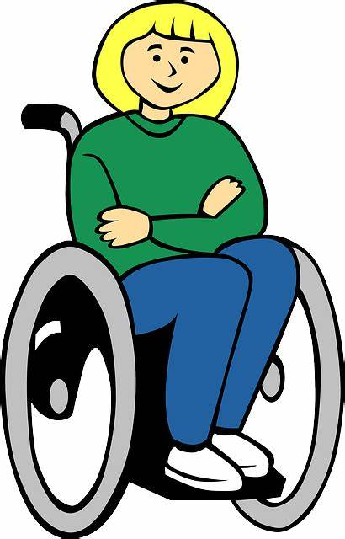
Image vectorielle gratuite: Fauteuil Roulant, Séance ... by Unknown Author

Wheelchair access

The ICC is fully accessible for wheelchair users using both ramps and lifts.

If you use a wheelchair or scooter and wish to bring this to the event you are welcome to do so.

Wheelchair availability:
The venue has two manual wheelchairs which can be borrowed.

Assistance
You will need to arrange your own assistance for pushing a manual wheelchair if you require this at the event.

Support/volunteers

There will be a team of volunteers who have an awareness of the inclusion of people with a disability.

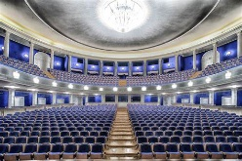

Conference Halls

Access
The venue main entrance is accessible via a ramp. There is also lift access to all levels. Escalators and stairs are also available.

Commissioning
The commissioning will take place in Hall 1, where wheelchair spaces are available.

These seats are situated in an open space on the same level as the concourse, so there are no steps to navigate.

All accessible seating is positioned near exits and within a close distance to accessible toilets.

Other activities
All the other halls have chairs which can be moved so there will be an option to choose the location where you are seated.

Assistance
The ICC staff will be present at the hall entrance to help direct delegates.

Use of Electrical Equipment
There will be charging points available in every meeting room and hall including the auditorium.

If you require a power supply for medical reasons or for your equipment during the event, please let us know via enabled@salvationarmy.org.uk

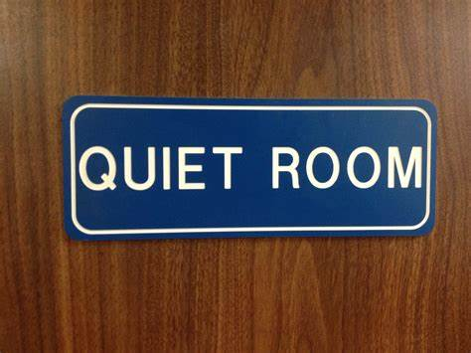

Quiet Room
As part of Together22 there will be many different activities taking place.

To assist people who can become overwhelmed by a busy environment, a quiet room will be available.

Volunteers will be able to direct you to the quiet room and there will be signs and directions displayed at the ICC.

Assistive listening devices
An induction loop system, which can be linked to visitors’ hearing aids, is operated in selected halls.

There will be free infrared hearing devices available to borrow at the venue. If you require an infrared hearing device, please speak to our team on arrival.

British sign language
There will be a BSL translator for the main events.

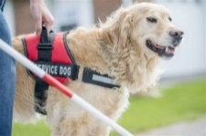

Assistance/guide dogs
Assistance/guide Dogs are welcome at the ICC. Please bring your own water bowls.

The ICC might be particularly busy and noisy, if your assistance dog requires a quiet space, there are open spaces outside and around the ICC Birmingham where you can take your assistance dog for a break.

Support for visual impairment
Signage
All rooms, halls and toilets are signposted in large print.

Support
ICC staff are available to assist delegates at the event or to their seat if required.

Salvation Army volunteers will be available on-site to support delegates where required.

Alternative format
Alternative formats (printed, large print, audio, etc.) of the event information can be provided on request.

If you require an alternative format of the event information such as posters, programmes or this document please contact us via enabled@salvationarmy.org.uk.

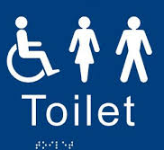

Accessible toilets
Toilets for people with disabilities are located throughout the venue on every floor.

They have an alarm pull cord system and are unisex.

They are within easy reach of any location inside the venue.

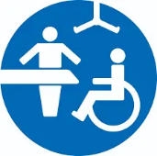

Changing places
The ICC Birmingham does not have any changing places facilities however there is a room available which can be used for changing. If you would like to use this room, speak with our team on the day.

Changing places toilets are available nearby at:
- Birmingham library (on the lower ground floor)
- Utilita Arena (on the concourse opposite Block 5)

Tickets
Tickets cost £10 per day for adults. Under 18 go free.

If you have any difficulties with the booking forms, please seek assistance from a family member or a Corps Officer.

Please book your ticket online:
https://www.ticketsource.co.uk/salvationarmyevents

First Aid/Emergency
Fire emergency
The ICC Birmingham security staff are trained in emergency evacuation procedures for those with limited mobility.

In the event of an evacuation, you will be escorted to the nearest refuge. If you have an assistance dog, the dog will also be evacuated to the refuge.
First aid
The ICC Birmingham staff are trained in First Aid. The Salvation Army will also have first aiders on site.

Contacts and More Information
If you would like any further information or would prefer to discuss specific requirements before booking, please get in touch with our team via enabled@salvationarmy.org.uk.

We will endeavour to ensure that everyone feels included and has the best experience during Together22.

Please provide information about your access requirements prior to the event so that our team can plan for appropriate support.

Regarding disability requirements:
Email: enabled@salvationarmy.org.uk
Telephone: 07341 084197

Event link: https://www.salvationarmy.org.uk/Events/Together22

