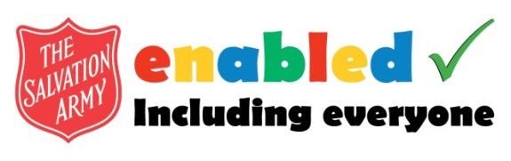 | APPLICATION  FORM

ABOUT US
enabled is a member led organisation that provides spiritual and social fellowship for people with a disability and their carers whilst cultivating an inclusive attitude and approach for people with a disability. Membership of enabled is open to anyone with any form of disability or who cares for someone with a disability be this a family carer, paid carer or friend.

1. About you

Name
Address

Telephone
e-mail
Date of birth

2. About your Corps or church

Corps or Church

3. Endorsement

Corps Officers/Church Ministers Signature |  | Date

4. Newsletter

How would you like to receive your copy of the newsletter?
PLEASE TICK THE BOX BELOW:
Printed version by post
PDF version by email
Audio version

5. Tell us about yourself

Please use the box below to tell us a little bit about you. This can include information about your disability, your hobbies, interests and achievements.

6. Your signature

Signed |  | Date

Return to: Chris Stringer, The Salvation Army,
101 Newington Causeway, London, SE1 6BN
Email: enabled@salvationarmy.org.uk

