Territorial activities
Summer School of Arts
The Summer School of Arts is a residential week in Cheltenham.
The week is a time of fellowship and support as well as the opportunity to form friendships. Activities within the week include:
 | Choir |  | Drama
 | Dance |  | Timbrels
 | Band |  | Day Trip
 | Bible Study |  | Swimming

Other activities
Other events and activities are organised from time to time.
For more information about enabled
By post : The Salvation Army,
101 Newington Causeway, London, SE1 6BN.

By email to: chris.stringer@salvationarmy.org.uk

By telephone to: 02076017026 or 07889755067

INFORMATION LEAFLET

All one in Christ (Galatians 3:28)

What is enabled?
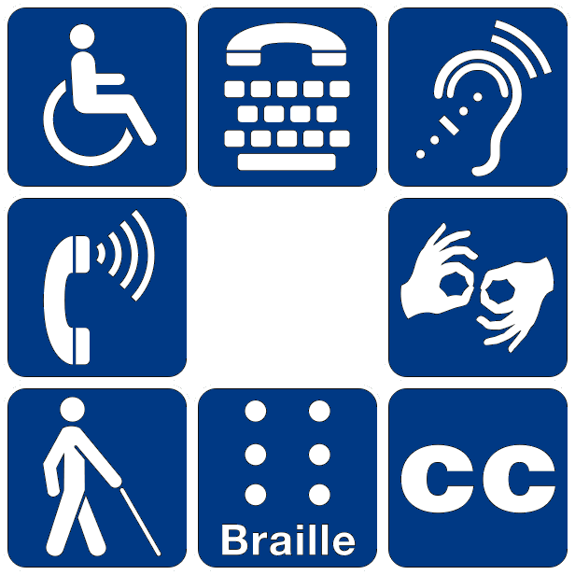 | enabled exists to provide spiritual and social fellowship for people with a disability and their carers.
We seek to cultivate an inclusive attitude and approach for people with a disability.

Who is enabled for?
enabled membership is open for anyone with a disability and their carers regardless of age.
enabled members do not have to be members of The Salvation Army.

OUR Newsletter
Each member receives a newsletter, which is called OUR Newsletter.
The aim is to produce OUR Newsletter four times a year.

OUR Newsletter contains information about members, enabled activities and a spiritual message. enabled members submit articles to be included in the newsletter.

OUR Newsletter is available in three formats
 | Print including large print
 | Audio
 | Email
You tell us which format you prefer.

Local groups
Corps
Some corps have local groups specifically for members of enabled
Many corps have weekly activities which enabled members can attend.
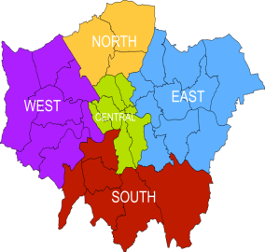 |  | Divisions  some divisions have groups for members of enabled they organise events and activities throughout the year.
Facebook
We have an enabled facebook group.
This is an opportunity for enabled members to share news, make prayer requests, offer advice and support each other.

