EXPRESSION OF INTEREST: OVERSEAS TRIP

About the trip
Change this highlighted section to make the information specific to your intended trip.

Keep it as succinct as possible, but as a minimum you should include:
- the probable destination of the trip
- the approximate timing of your trip (this is to make it easier for those who work to check for prior commitments and/or to pencil it into their diary)
- the duration of the trip (how much time will people need to book off work?
- the estimated cost of the trip (this will be very much a ballpark figure, but people need to judge if they can afford it)
- the trip’s possible purpose/aims (although these must be led by your partner, not you)

About this form
The purpose of this form is primarily to gauge the level of interest in the trip. In giving your details at this stage you are merely saying that you want to find out more. You are not committing to the trip, simply giving us permission to keep you updated with new information. You can opt out of this at any time.

If at a later stage you do decide to commit to the trip, you will need to sign a Suitability Declaration giving details of any criminal background, and your suitability will be checked and verified by the corps officer. Three months before the trip you will also need to sign a Code of Conduct (examples of both are below).
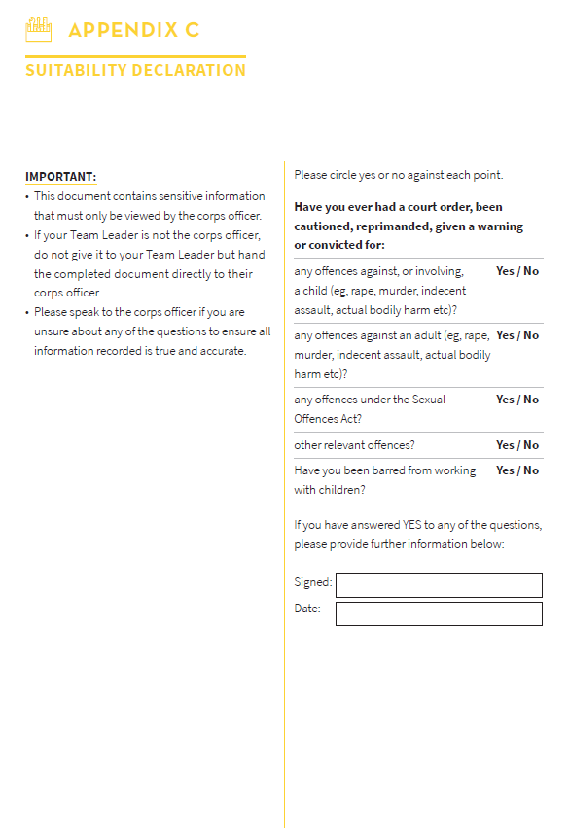 | 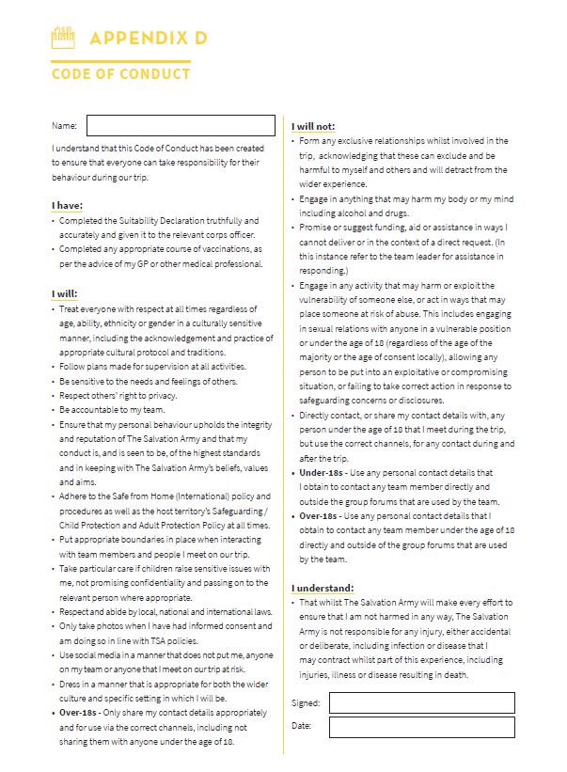
About you
Full name*
Age* (or D/O/B if under 18):
If you are under 18 you must give your parent/guardian’s contact details below, not your own.
Mobile phone*
Email*

About your rights
- In line with current GDPR guidelines, we need your permission to contact you. These communications will only be related to information about the trip and for no other purposes.
- Communications will only come via the Team Leader through previously approved channels.
- If you are under 18, all communication will be via your parent/guardian.
- We will protect your data by not sharing it with anyone outside the project, for example by sending WhatsApp messages via a Broadcast List rather than through a normal WhatsApp group.
- We will retain your data until whichever comes first: the trip debrief is completed, or you decide you no longer want to receive updates about the trip.
- By ticking the box below and signing you give your permission to be contacted as defined above. You can withdraw this consent at any time by speaking to the Team Leader.

- I give permission for the above named person to be contacted as defined above.

Signature: |  | Date:
Name and relationship to the person named above, if you are signing on their behalf:

