Instruction Guide

Items needed:
- ‘Displays 1,2, 3’ and ‘Activity Sheet 1’ printed
- A table and table cover (decorative option)
- Chairs around the station (if applicable)
- Scrabble or Bananagrams letters
- Colouring pencils

Sensory element
Decorate the table with real palm leaves for people to touch and smell.

Description
Place ‘Displays 1 and 2’ on the table. Cut out however many quantities needed of ‘Activity Sheet 3’ and provide colouring pencils.

Place the Scrabble or Bananagrams letters all together in a bowl or on the corner of the table alongside ‘Display 4’. You may want to connect a couple of words to start people off.
Example:
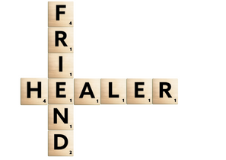

Display 1

‘A very large crowd spread their cloaks on the road, while others cut branches from the trees and spread them on the road. The crowds that went ahead of him and those that followed shouted, “Hosanna to the Son of David!” “Blessed is he who comes in the name of the Lord!” “Hosanna in the highest heaven!” When Jesus entered Jerusalem, the whole city was stirred and asked, “Who is this?”’
(Matthew 21:8-10)

Display 2

The people waved palm leaves to welcome Jesus into Jerusalem.
How are we welcoming Jesus into our lives daily? How are we welcoming others?
Colour in the word ‘Welcome’ and keep it somewhere visible as a reminder for yourself, or give it to someone who may need to feel welcome.
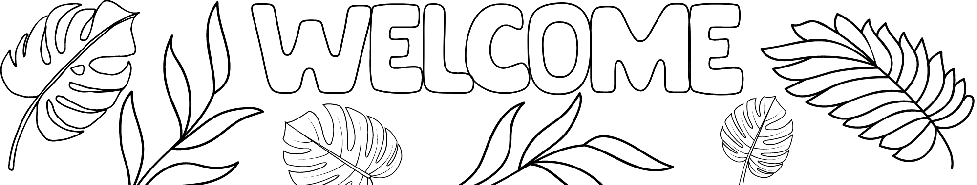
Activity 1
Display 3

Jesus invites each one of us to faithfully follow him. Respond to his invitation and use the letters to form a word that describes who Jesus is to you.

Pray that he will help you to faithfully follow him.

