Instruction Guide

Items needed:
- ‘Displays 1,2,3,4,5,6,7’ and ‘Activity Sheet 1’ printed
- A table and table cover (preferably purple as a decorative option)
- Chairs around the station
- Newspapers headlines and articles on suffering
- A large map of the world, or a globe
- Post-it Notes
- Nails, a piece of wood and a hammer
- Pens and colouring pencils
- A bin

Sensory element
Provide a crown of thorns for people to touch.

Description
Place ‘Displays 1,2,3,4,5,6,7’ on the floor or on the table or on a wall alongside any respective props. Cut out however many quantities needed of ‘Activity Sheet 1’ and provide colouring pencils. You may want to provide cushions or chairs for people to feel comfortable.
Note: ‘Display 2’ is an alternative to ‘Display 3’ if you don’t have access to a world map or globe.

Display 1

‘Then Pilate took Jesus and flogged him. And the soldiers twisted together a crown of thorns and put it on his head and arrayed him in a purple robe. They came up to him, saying, “Hail, King of the Jews!” and struck him with their hands. Pilate went out again and said to them, “See, I am bringing him out to you that you may know that I find no guilt in him.” So Jesus came out, wearing the crown of thorns and the purple robe. Pilate said to them, “Behold the man!” When the chief priests and the officers saw him, they cried out, “Crucify him, crucify him!”’
(John 19:1-6 ESV)

Display 2

Jesus’ suffering means that there is no pain too great in this world that he cannot identify with.

Look at the newspaper headlines/articles and take time to pray for the different situations you see.

Display 3

Jesus’ suffering means that there is no pain too great in this world that he cannot identify with.

On the Post-it Notes write prayers for areas of the world in which you know people are suffering deeply right now and place them on the map.

Display 4

‘For God so loved the world that he gave his one and only Son, that whoever believes in him shall not perish but have eternal life.’

(John 3:16 NCV)

Display 5

After Jesus had hung on the cross for six hours, Jesus gave up his spirit.
‘“At that moment the curtain of the temple was torn in two from top to bottom. The earth shook, the rocks split and the tombs broke open…When the centurion and those with him who were guarding Jesus saw the earthquake and all that had happened, they were terrified, and exclaimed, “Surely he was the Son of God!”’
(Matthew 27:51–52a, 54)

Display 6

Take a nail and hammer it slowly into the piece of wood.

It’s hard to imagine the pain Jesus endured. He suffered not because of his own sins, but because of your sins. Take some time to contemplate this and what his sacrifice means for you.

(Safety warning – please be careful when handling the hammer and nails.)

Display 7

Despite all he was enduring, Jesus’ final words on the cross were still of love and mercy: ‘“Father, forgive them, for they do not know what they are doing”’ (Luke 23:34). It can be hard to forgive others and even ourselves.

Fill in the appropriate blank spaces in the ‘Prayer of Forgiveness’.

Once you have prayed, rip up the card and put it in the bin as a sign of forgiveness.

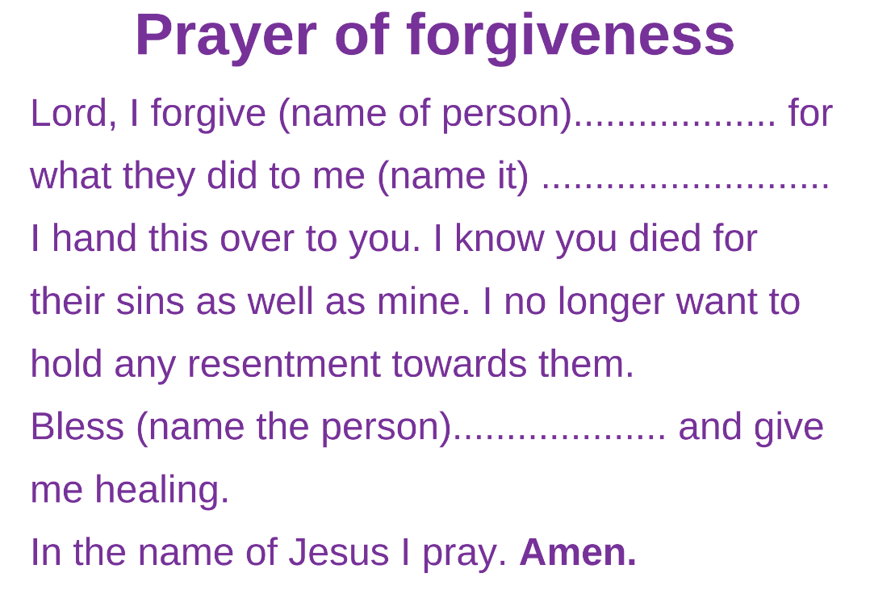
Activity Sheet 1

