Advent Reflection – Leader’s Notes
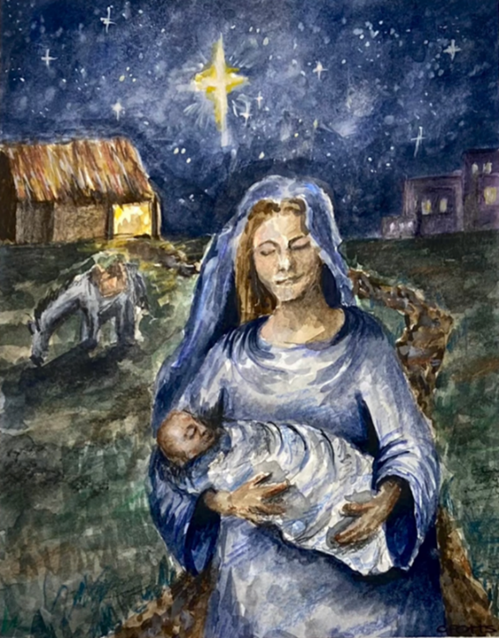

The aim of this exercise is to listen and respond to God. This may be something you complete by yourself, in a small group or as part of congregational worship. Take this time to reflect and be in God’s presence.

Stop: Watch the video of the artwork being created.

At the end of the video, show the completed image on screen. Spend some time in silence gazing at the image.

Read: Have a reader speak God’s word while the image remains on screen. Suggested Bible readings: Luke 1:46-53; Isaiah 9:2-6; Luke 2:15-20.

Reflect: Which part of the image catches your attention? Hold your attention on that part of the picture. Why are you drawn to that part of the image?
Now look at the full image and imagine you are there. What can you see from where you are? What can you smell or hear? How do you feel?

After seeing this sight, the shepherds sang God’s praises, the wise men fell to their knees. What are you going to do?

Respond: Spend time in prayer and give thanks to God for the gift of his Son – may we be more like the shepherds and wise men this Advent and Christmas time.

