# KINDNESS AND INCLUSION

MISSION PRIORITIES

## PREPARATION

* If you know an *Enabled* member, ask them to speak about what Enabled means to them
* Pen and paper for each member
* Print a copy of the *Disability, inclusion and enabled* info pack for each member
* Research more information about [Enabled](http://www.salvationist.org.uk/faith/our-territory/territorial-directory/enabled) and prepare to share some Enabled videos
* Prepare a ‘Kindness’ grab bag – include a small snack, a bandage, a bottle of water, a greetings card, and a small chair, eg a dolls’ house chair or picture of one

Additional resource

* *Disability, inclusion and enabled* info pack

## INTRODUCTION/BACKGROUND

Today we're going to look at the subject of how we can serve without discrimination. We're going to look at an area of The Salvation Army’s ministry called *Enabled*.

*Enabled* is a part of The Salvation Army that helps those with disabilities participate in all activities within the church; they ensure that every programme is an opportunity for every person to be included. We’re going to educate ourselves in what *Enabled* does, alongside thinking about how the Bible also explores this subject of inclusion.

We’ll look at a story from the Old Testament in 2 Samuel Chapter 9. It tells how King David was kind to the grandson of the late King Saul. This grandson had disabilities and might have felt he didn’t belong at the king’s table. But David’s kindness made sure he was included and treated equally.

## ACTIVITIES

### SHARE

Ask members to share their thoughts.

* Have you ever been invited out for a delightful dining experience?
* Do you have a favourite restaurant?
* Has someone special ever prepared your favourite meal for you?

Then ask:

* If you were to prepare a meal for an esteemed guest, what would you cook? Please encourage members to use their imagination; it does not matter if culinary skills are not their forte – just let the creativity flow.

Ask members to list their starters, main course and dessert, then compare their unique meal ideas.

Perhaps once members have shared these ideas, the group could choose whose menus they would prefer.

#### Play

You can turn the menus ideas into a game similar to Consequences. Each person writes or draws their favourite starter at the top of a piece of paper, then folds it over and hands it to the next person. Next, they write or draw their main course, fold the piece of paper, and hand it to the next person. Finally, they write or draw their favourite dessert. At this point, they unfold the paper and take turns revealing the *Menu of the day*.

#### Thought

We each have distinct preferences and concepts of the ideal menu, but one common goal is to make our guests feel welcome. It is important to ensure that they know a place has been prepared for them at the table and that special efforts were made to include them.

Today’s Bible account is from 2 Samuel 9. King David wanted to show kindness to any remaining family of the late King Saul. He asked his servant: *‘Is there no one still alive from the house of Saul to whom I can show God’s kindness?’* (2 Samuel 9:3)

And so Saul’s grandson Mephibosheth, who was disabled and living in a desolate place, was found. David showed him kindness by inviting Mephibosheth to the palace, offering him a place at his table, restoring his inheritance and ensuring he was always cared for.

### ENABLED

If you know an *Enabled* member, ask them to speak about what *Enabled* means to them.

Share the *Disability, inclusion and enabled* info pack with members to find out what The Salvation Army does in the UK and Ireland. Give time to read as much or as little as is required, allowing members to take the information home to read in more detail.

You may wish to share the following videos.

* [*The Music Man Project*](http://www.youtube.com/watch?v=OSp--z-pdk8) by The Salvation Army UK and Ireland (3:03)
* [*The 2019 Enabled song*](http://www.youtube.com/watch?v=lKCw9uOuAL4) by SA Stu (3:31)

#### Discuss

Discuss with members what they have learned; what words and phrases stood out for them? What impact is *Enabled* having? How can we, as a church and as individuals, be more inclusive, to help people belong?

## BIBLE READING/THOUGHT

🕮 2 Samuel 9

This chapter is only 13 verses long, yet it highlights the significance of kindness and inclusion.

The backstory is that David spent many years running from King Saul, who was jealous and unwilling to relinquish the throne that God was now giving to David. Despite this, David shared a close friendship with Saul’s son, Jonathan. Before David fled, he made a promise with Jonathan always to look after each other’s families.

This brings us to 2 Samuel:9. Having experienced significant blessings, David decides to show the same kindness he received by reaching out to Jonathan’s last living relative and inviting him into his home. David could have been unkind or selfish but instead chose to share generosity and include this individual in his blessings.

The principle of kindness can extend from us to others – through supportive actions, understanding and grace – particularly towards those facing greater challenges in life. Often individuals with disabilities encounter additional difficulties and smaller social circles due to misunderstanding or prejudice. Like David, we can reach out to others, showing acts of kindness and making intentional efforts to include them.

Intentionally being kind and inclusive can demonstrate compassion and support in this often challenging world.

Members of the *Enabled* group often find themselves in situations comparable to those experienced by King Saul’s grandson. They may experience feelings of isolation, require assistance with daily tasks, and have concerns about their future or the wellbeing of their loved ones. Despite these challenges, they possess a wealth of love, experience, insight and enjoyment, and have testimonies to share.

The *Enabled* community provides substantial support, spiritual guidance, inclusion and enjoyable activities, consistently embodying the welcoming spirit at the King’s table. In this challenging world, we are encouraged to act with kindness and extend an invitation to others to join the King’s table.

### REFLECTION

Here are some prompts that may encourage thoughtful and inclusive actions. Use the ‘Kindness’ grab bag to demonstrate:

* **A snack:** consider baking a cake, sharing a meal, or taking someone out for a bite to eat.
* **Bandages:** offer help or advice to someone who needs support.
* **Water:** a nice cup of tea can brighten someone’s day and make them feel included.
* **Card:** send a card, write a note or email to ensure others don’t feel isolated.
* **Chair:** take the time to welcome others, making sure they feel special and included.

### PRAYER/POEM

Looking after number one,

Dismissing other’s needs,

Is not the path to greatness,

Not found in Christian creeds.

Looking after number one

Was not in Jesus’ mind;

He sacrificed his selfless life

To save proud humankind.

True greatness comes through serving,

He made his message plain;

For that’s God’s way of making

Humanity great again!

Commissioner Robert Street

## SONGS

The songs selected all feature Makaton, a communication aid for adults and children.

* ‘Bless the Lord, O my soul (10,000 reasons)’ by Matt Redman

[Makaton lyric video](http://www.youtube.com/watch?v=uQHO3112td0) by Worship Lyric Videos (4:22)

* ‘Light of the world (Here I am to worship)’ by Chris Tomlin

[Short Makaton lyric video](http://www.youtube.com/watch?v=jUWlPeNI_o8) by Worship Lyric Videos (0:59)

[Makaton lyric video](http://www.youtube.com/watch?v=8T4Dnw6xQSs) by Becky George (low volume video) (5:07)

* ‘Faithful one’

[Makaton lyric video](http://www.youtube.com/watch?v=rabHAbyCIh8) by Becky George (low volume video) (4:38)

* ‘My Lighthouse’ by The Rend Collective

[Makaton lyric video](http://www.youtube.com/watch?v=d5RSzFQIfvc) by Becky George (low volume video) (3:47)

* *SASB* 208 ‘When I survey the wondrous cross’

[Short Makaton lyric video](http://www.youtube.com/watch?v=3augVxbxf0U) by Worship Lyric Videos (0:54)

## WEBSITE AND CONTACT DETAILS

* Connect website: [www.salvationarmy.org.uk/connect](http://www.salvationarmy.org.uk/connect)
* Family Ministries website: [www.salvationarmy.org.uk/families](http://www.salvationarmy.org.uk/families)
* Emails: [familyministries@salvationarmy.org.uk](mailto:familyministries@salvationarmy.org.uk)
* Facebook: @sarmyfm
* Twitter: @ukifamily
* Instagram: safamily_ministries

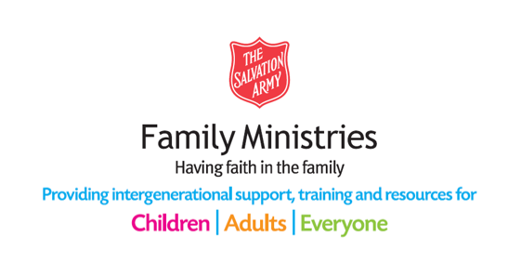

## DISABILITY, INCLUSION AND ENABLED INFO PACK

# Disability and inclusion

Many people with disabilities face barriers when joining in churches and communities’ activities.

Our mission is to embed practices that ensure people with a disability are given real opportunities to participate in every activity of The Salvation Army. This means that the starting point for any activity – be this worship, the provision of a service, a community programme or volunteer opportunity – is that everyone with a disability will be included as an equal.

### How can we help?

We provide information, guidance, advice and support to officers, staff and volunteers as well as individuals attending corps or Salvation Army programmes and activities.

* Accessibility audits
* Accessible church sessions
* Accessible information
* Disability and neurodiversity training

### To find out more about disability and inclusion contact us

|  |  |
| --- | --- |
|  | |
| photo of Jo-Anne Graham | **Jo-Anne Graham**  Email  joanne.graham@salvationarmy.org.uk  Phone: 07341 084197 |
|  |  |
| photo of Richard Knott | **Richard Knott**  Email  richard.knott@salvationarmy.org.uk  Phone: 07774 619500 |
|  |  |
| photo of Chris Stringer | **Chris Stringer**  Email  chris.stringer@salvationarmy.org.uk  Phone: 07889 755067 |



# enabled

### What is Enabled?

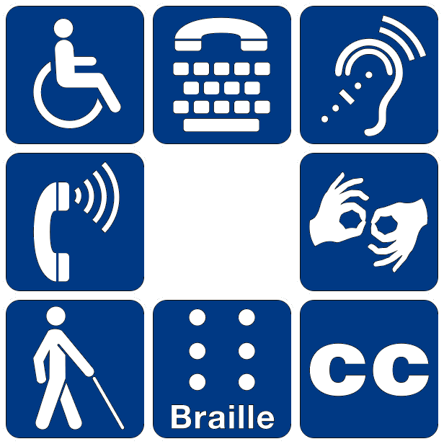*Enabled* is a Christian community that provides empowering spiritual and social fellowship for people with disabilities, alongside their families and carers.

We seek to cultivate an inclusive attitude and approach so that people with a disability feel like they truly belong.

The aim of *Enabled* is for every member to have access to

shared worship, fellowship and Christian social activities.

The *Enabled* community offers members a fellowship that is accessible at whatever level they need.

### Who is Enabled for?

*Enabled* membership is open to anyone with a disability, their family members, friends and carers regardless of age.

*Enabled* members do not need to be members of The Salvation Army to join.

### What we do?

picture of a newsletter 

#### Our Newsletter

*Our Newsletter* is produced by and for our members.

Produced in an accessible format, it contains news, member stories, Enabled event articles, relevant topical information, a time of reflection, photographs and much more.

Every corps in the territory receives a copy.

You can get a copy of *Our Newsletter* by email or have a hard copy delivered to your home address.

To join our mailing list:

#### Email

[**enabled@salvationarmy.org.uk**](mailto:enabled@salvationarmy.org.uk)

**The prayer network image of praying handsPrayer Network**

A weekly email, usually on a Friday, which includes a passage from the Bible, a message of encouragement, news, information and suggestions of people and things to pray for.

Would you like to join the Enabled Prayer Network?

#### Email

[**enabled@salvationarmy.org.uk**](mailto:enabled@salvationarmy.org.uk)

### the keeping in touch logo imageKeeping in Touch

Two out of five people with disabilities often feel isolated and alone.

Keeping in Touch is our telephone befriender service that gives our members the opportunity to stay connected.

The chance to speak with someone and laugh with them can cheer us up and lighten our day.

To join, or if you’re interested in becoming a volunteer telephone befriender:

#### Email

[**enabled@salvationarmy.org.uk**](mailto:enabled@salvationarmy.org.uk)

### the music man project logo imageThe Music Man Project

*The Music Man Project* is an award-winning and fully accessible music service for adults and children with disabilities.

It provides accessible tuition, fun and access to inspirational performance opportunities. The groups learn original songs, how to play instruments and Makaton signs.

Across the territory *The Music Man Project* has developed opportunities for people with disabilities to build confidence and connect through music.

To find out more about *The Music Man Project* in your area or how to start up a local group at your corps/centre:

#### Email

[**enabled@salvationarmy.org.uk**](mailto:enabled@salvationarmy.org.uk)

### the enabled logoSummer Extravaganza

The Summer Extravaganza is a week-long residential event for members.

It is a week of faith, fellowship, friendship and fun. Most of our activities and worship sessions are member-led.

We provide a fully accessible programme of activities that includes music, craft, sport, dance, timbrels, contemporary band and video production.

We host themed nights including movie nights, a talent night and a disco.

Our community open day and final celebration events ensure that families and friends can join in too.

If you are interested in coming along or would like to volunteer as a supporter:

#### Email

[**enabled@salvationarmy.org.uk**](mailto:enabled@salvationarmy.org.uk)

### Facebook - Free social iconsFacebook

Our Facebook group is a very active community that has 1.3 thousand members.

#### Search

enabled (The Salvation Army)

### a picture of the WhatsApp logoWhatsApp

The enabled WhatsApp group allows members to share news, prayer requests and provide peer support.

For more information about how to join the WhatsApp group:

#### Email

[enabled@salvationarmy.org.uk](mailto:enabled@salvationarmy.org.uk)

### a picture of the YouTube logoYouTube

We have an enabled YouTube channel where you can see clips of our online events as well as the Enabled Extravaganza.

#### Search

enabled (Salvation Army)



### Pastoral Care

*Enabled* members receive telephone or video calls including offering a listening ear and the opportunity to share in the Bible and have a time of prayer.

Some Enabled members prefer to have contact by letter or card.

To become a member of the Enabled fellowship:

#### Email

[enabled@salvationarmy.org.uk](mailto:enabled@salvationarmy.org.uk)

### Image result for zoom clip artAccessible Worship

Our worship sessions are held on Zoom and led by Major Richard Knott.

We have produced accessible information guides to help members access Zoom on their phone, tablet or laptop.

For more information about how to join in:

#### Email

[enabled@salvationarmy.org.uk](mailto:enabled@salvationarmy.org.uk)

### Session icons for free download | FreepikEnabled at Easter and Christmas

We host a full programme of online, accessible activities on Facebook live, YouTube and Zoom.

For more information:

#### Email

[enabled@salvationarmy.org.uk](mailto:enabled@salvationarmy.org.uk)

### logo for more information.Enabled meetings and events

We hold Enabled events across the territory, and some divisions have local Enabled group meetings that are held on a regular basis.

To find out what’s happening in your area or if you want to find out how set up an Enabled group in your area:

#### Email

[enabled@salvationarmy.org.uk](mailto:enabled@salvationarmy.org.uk)

### How do I become a member?

If you are interested in becoming a member of the Enabled fellowship:

#### Email

[**enabled@salvationarmy.org.uk**](mailto:enabled@salvationarmy.org.uk)