# Building up to your Harvest offering

**Creative ways to promote Harvest in the weeks leading up to your celebration.**

**The intention of this resource is to build intrigue and inspiration in your corps as members prepare their hearts for giving.**

**Silent Theme Build-up**

This year’s resources are shaped around the theme ‘*What’s growing here?*’. Stir intrigue and begin conversations around Harvest by placing a plant somewhere in **clear view or a busy area** for the three weeks leading up to your Harvest celebration.

***Option 1***

Week 1: Place a strong houseplant in a visible spot with an envelope subtly attached to a leaf – and no context or explanation. Inside the envelope include a card that simply reads: *‘What’s growing here?’*

Week 2: Change the envelope’s colour or add a second one. Inside this time place a new card which reads: *‘We give thanks.’* The layered addition continues the intrigue while gently deepening the theme. By this point, people may start to link this with Harvest.

Week 3 (Week before Harvest): Introduce a third envelope – or change the colour again. Inside a final card reads: *‘We give back.’*

To add further depth, include a relevant Bible verse and/or prayer on each card.

Let the progression unfold without announcements, building silent anticipation and spiritual reflection leading into Harvest.

NB Remember to keep the plant healthy!

***Option 2***

Here is a visual representation.

**Week 1:**

Place a plant in a visible spot with an envelope subtly attached to a leaf – and no context or explanation. Inside the envelope include a card that simply reads: *‘What’s growing here?’*

**Week 2:**

Remove the envelope leaving the card on display. Place extra pegs and cards next to the plant for people to answer the question on. Place one or two on the plant yourself as an example for others to follow.

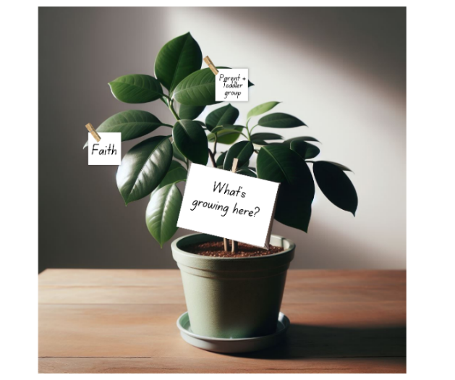

**Week 3 (Week before Harvest):**

Add a second plant. On the second plant place a card with the writing *‘What do you hope to see grow here?’* and replenish the pegs and cards for people to write on. Let people continue to fill both plants.

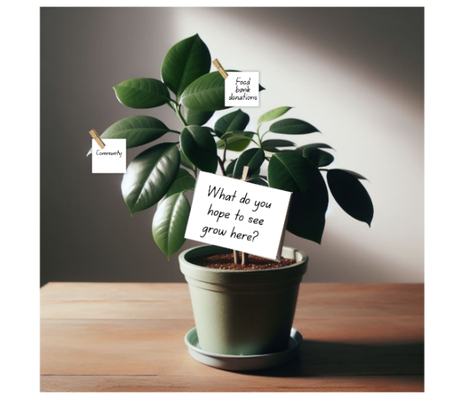

**Harvest Video Build-up**

Play the longer video to your corps **before** your Harvest Festival to support giving and inspire local mission. Then, on the day of your Festival, play the shorter version both to support that final time of giving and to celebrate with those who have already given.

Make use of the social media templates and poster to promote your service further.

**Four-week Devotional**

You may wish to adapt and build on the below structure for your context. This devotional is written to be used on the lead-up to your Harvest Festival.

Here are a range of ways to use this devotional:

* Print it out or email it to your corps members as one document at the start of the four-week lead up to Harvest.
* Give it out alongside the Harvest giving envelope and letter.
* Hand out each week’s devotional as devotional cards in your service.
* Use as weekly social media content.
* Use as sermon starters to inspire a sermon or small group series.

**Week 1: Preparing the Ground**

**Theme:** Heart readiness   
**Scripture:** *Hosea 10:12* – ‘Break up your unploughed ground; for it is time to seek the Lord …’  
**Devotional Thought:**  
Just as soil must be softened before seeds can take root, our hearts must be prepared for the work God desires to do. This season invites us to surrender our distractions and tend to the quiet spaces within, making room for God to move.  
**Prayer Prompt:**  
*Lord, soften my heart. Show me where you’re calling me to make space for new growth.*  
**Challenge of the Week:**  
Take 10 minutes daily to sit in silence, asking God to reveal what’s beneath the surface.

**Week 2: Planting with Purpose**

**Theme:** Intention and vision  
**Scripture:** *Ecclesiastes 11:6* – ‘Sow your seed in the morning … for you do not know which will succeed …’  
**Devotional Thought:**  
Every kind word, act of service or faithful decision is a Kingdom seed. We don’t always see instant results, but purposeful planting is an act of faith. What are you sowing into your community or relationships right now?  
**Prayer Prompt:**  
*God, give me boldness to plant with purpose and hope – even when results aren’t visible.*  
**Challenge of the Week:**  
Write down one thing you intend to plant this week: a prayer, a conversation, a gift. Then do it.

**Week 3: Nurturing Growth**

**Theme:** Trust and patience  
**Scripture:** *Galatians 6:9* – ‘Let us not become weary in doing good, for at the proper time we will reap a harvest …’  
**Devotional Thought:**  
Growth doesn’t happen overnight. Whether it’s in your faith, your mission, or unanswered prayers, God’s timing is perfect and his nurture is constant.  
**Prayer Prompt:**  
*Lord, help me to persevere and trust you with the growth I cannot yet see.*   
**Challenge of the Week:**  
Encourage someone else’s growth – send a message, say thank you, or affirm what God is doing in their life.

**Week 4: Celebrating the Fruit**

**Theme:** Gratitude and testimony  
**Scripture:** *John 15:5* – ‘I am the vine; you are the branches … apart from me you can do nothing.’  
**Devotional Thought:**  
The fruit we celebrate – healing, transformation, unity – is all from abiding in Christ. Take time to notice where God has been faithful. Every answered prayer, every restored heart is worth sharing and celebrating.   
**Prayer Prompt:**  
*Jesus, thank you for the fruit of your Spirit and the harvest you’ve grown in me.*  
**Challenge of the Week:**  
Share a testimony with someone, either in person or online. Let praise overflow!