# APPRECIATING GOD’S GIFT OF CREATION

MISSION PRIORITIES

## PREPARATION

* Ask a member or two to talk about or share any knowledge they have about the natural world
* Research nature facts to share, eg [onetreeplanted.org](https://onetreeplanted.org/blogs/stories/nature-fun-facts)
* Find pictures depicting different scenes of nature and places (use old calendar pictures or from [Unsplash.com](http://www.unsplash.com))
* Provide a flower for each member to take home

Additional resource

* *Who am I* picture quiz

## INTRODUCTION/BACKGROUND

Experts say that taking a walk or immersing ourselves in nature, like a spot of gardening or planting, is good for us. A walk in the fresh air can make us feel invigorated and refreshed, and is not only good physically but helps our emotional wellbeing too. Maybe you simply love sitting on a warm day in your garden, appreciating the sights and sounds around you. It may be that you are an avid nature lover and enjoy nothing more than a good cup of tea watching a David Attenborough documentary.

The truth is that creation is a wonderful place. When we take time to pause and think, it never ceases to fill our hearts with wonder at God’s imagination and creativity. It should make us feel in awe of him and spur us on to worship him even more. There is so much to learn about nature – it is complex, miraculous, beautiful and awe-inspiring.

‘Care for creation’ is one of the five Salvation Army Mission Priorities. In this session we will worship and thank God as we consider the wonder of his design and how we can use nature as a means of connecting with him. We will also consider our responsibility in being good stewards of his gifts as a response of gratitude for them.

## ACTIVITIES

### SHARE

Encourage members to share their thoughts, experiences or knowledge about the natural world. For example:

* What is your first memory of nature?
* What experience of nature filled you with wonder?
* What fascinating fact do you know about the natural world?
* Where do you go to experience God’s creation?
* What do you do to help look after God’s creation?

#### Thought

It is important to take time to appreciate what we have, but also to be responsible in looking after his gift of nature.

### TALK

Perhaps a member or two can give a talk or bring in examples of a hobby or interest relating to the natural world, eg animals, plants or geology.

### FACTS

#### Did you know …?

Share some amazing facts about nature with the group, eg from [onetreeplanted.org](https://onetreeplanted.org/blogs/stories/nature-fun-facts).

1. What is the Wood Wide Web?
2. Which sea creature has names for each other?
3. Which herd of animals votes on travel decisions? And how do they cast their votes?
4. Which plant is the fastest growing?
5. Which insects boogie to communicate?
6. Which is more – the number of trees on Earth or stars in the Milky Way?
7. What are birds descended from?
8. What is the largest animal ever known to exist?
9. Forests can create which natural phenomenon?
10. Do elephants actually have a good memory?
11. Which fish species is older than the dinosaurs?
12. Which sea creature may give a higher form of empathy than other animals?
13. What can trees do if they are attacked by an insect?
14. Which type of tree is more likely to be struck by lightning?
15. Which ‘whale’ is really a dolphin?

#### Thought

‘O Lord, what an amazing variety of all you have created! Wild and wonderful is this world you have made, while wisdom was there at your side. This world is full of so many creatures, yet each belongs to you!’

(Psalm 104:24 *The Passion Translation*)

Let us value God’s gift of creation in all its beauty and order, allowing it to draw us closer to God the giver and provider.

### QUIZ

Individually or in pairs, do the *Who am I?* picture quiz all about food!

#### Thought

God provides all we need through nature.

## BIBLE READING/THOUGHT

Use *SASB* 14 ‘For the beauty of the earth’

* [Piano instrumental lyric version](http://www.youtube.com/watch?v=R6KBulB3GV0&list=RDR6KBulB3GV0) (tune: ‘Dix’) by The Salvation Army Video Songbook (3:11)
* [Congregational lyric video](http://www.youtube.com/watch?v=VzlYTe8uNdY&list=RDVzlYTe8uNdY) (tune: ‘England’s Lane’, six verses) by Chet Valley Churches (3:06)
* [Congregational lyric video](http://www.youtube.com/watch?v=-E75VyLrygw&list=RD-E75VyLrygw) by Church of the Evangelists (tune: ‘Dix’) (2:52)
* [Soloist lyric video](http://www.youtube.com/watch?v=2a8v2MqO7yg&list=RD2a8v2MqO7yg) (tune: ‘Dix’) by Matt Beckingham (3:49)
* [Lyric video](https://www.youtube.com/watch?v=xlBkpAm3fhw) John Rutter version feat Cambridge Singers (verse three is not included) by Maylis Susan (3:35)

### Verse 1

Already we have had a glimpse into the wonder of our world. All of this is a precious gift from God, given out of love for us. Many of us are likely to have had some quite dubious gifts in the past! Probably we equally have had some special gifts. However, when we really begin to fully appreciate the world around us, we realise quickly that God’s gift of creation is the most wonderful precious gift ever!

### Verse 2

Have you ever taken time to sit and ponder on the order of nature? Think about the seasons and their cycle. Sometimes it feels like the seasons are not as defined as once were – it seems we can have floods in summer and flowers budding far too early before spring. Much of this is related to climate change and the way we have treated our planet. But, as it says in Genesis, God designed the world with order, and it works best when we work with nature rather than against it.

### Verse 3

Let’s think about our senses for a moment.

**Encourage members to participate and add their own suggestions or experiences.**

* **Sound:** The sounds of a bird chirping in the trees nearby. The sound of waves crashing upon the rocks.
* **Sight:** The sight of a newborn lamb in the field. The beauty of the butterfly as it flutters around the garden.
* **Taste:** The textures and flavours of so many different foods. Our individual taste buds.
* **Touch:** The soft grass, the fur of a rabbit, the embrace of a family pet.
* **Smell:** The aromas from a kitchen cooking something delicious. The sweetness of flowers. The smell of a new baby.

### Verse 4

Let’s consider the creation of humankind and our intricate design: our capacity to receive and give love; the preciousness of relationships and the depth and meaning they can bring; the joy of spending time with another and sharing experiences together.

### Verse 5

When we pause to think and reflect on all the blessings this world has to offer, we can do no other than come before the Lord in awe and wonder of his generosity and kindness. Sometimes we can get too caught up with the busyness of life and miss out on special significant moments that God gives us through nature. Quite often we can take things for granted, and sometimes it is good to have a child’s perspective to bring back some awe and wonder that as adults we at times lose. As we look around us and fully appreciate creation, we begin to appreciate even more the Creator and giver of this most wonderful gift. ‘Father, unto thee we raise this our sacrifice of praise.’

### REFLECT

#### Psalm 23

This psalm paints a lovely picture of God’s care, using imagery of green pastures and still waters.

**Share out the pictures of nature and different places. Give each person a few minutes to sit and take in what they see and what thoughts or feelings come to mind.**

May we take time and make a conscious effort to pause, listen, smell, and see the beauty of God through his handiwork right there in front of us. What message are we giving God when we don’t do that? What message are we giving out when we don’t look after our world and take good care of it? What does God think and feel when we don’t make time to worship and thank him for his goodness and generosity? May we never take anything for granted, and instead always nurture an attitude of gratitude.

### PRAYER

O God, [our] great Creator and Sovereign Lord of Heaven and earth, (…) Father of angels and men, (…) giver of life and protector of all [your] creatures, mercifully accept this my morning sacrifice of praise and thanksgiving, which I desire to offer with all humility to [your] divine Majesty.

[You are] praised, O Lord, by all [your] works, and magnified by every thing which [you have] created.

The sun [rejoices] to run his course, that he may set forth [your] praise who [made] him.

Nor do the moon and stars refrain to manifest [your] glory, even [among] the silent night.

The Earth breathes forth each day perfumes, as incense to [you], her sacred King, who has crowned her with herbs and trees, and [beautifies] her with hills and dales.

The deep [utters] his voice, and [lifts] up his hands on high to [you], the great Creator, the universal King, the everlasting God.

The floods clap their hands, and the hills are joyful together before [you]; the fruitful vales rejoice and sing [your] praise.

[You feed] the innumerable multitude of animals which [you have] created; these all wait upon [you], and [you give] them their meat in due season.

[You made] light for our comfort, and [brought] forth darkness out of [your] treasures, to overshadow the Earth, that the living creatures of it might take their rest.

The fire and hail, snow and vapour, wind and storm fulfil [your] word and manifest [your] glory.

Inanimate things declare [you], O Lord of life; and irrational animals demonstrate their wise Creator.

Amidst this universal jubilee of nature, [allow] not, I [beg you], the sons of men to be silent; but let the noblest work of [your] creation pay [you] the noblest sacrifice of praise.

O pour [your] grace into my heart, that I may worthily magnify [your] great and glorious name.

[You have] made me and sent me into the world to do [your] work.

O assist me to fulfil the end of my creation, and to [show] forth [your] praise with all diligence, by giving myself up to [your] service.

[Let] the work of my hands [thrive and grow], O Lord; [so that whatever work] I shall undertake this day, [may it be for your] glory, the good of my neighbour, and the salvation of my own soul.

John Wesley

*A Collection of Forms of Prayer* 1733

### REFLECT

Give each member a flower to reflect with and to take home, to help appreciate God’s gift of creation.

## SONGS

* *SASB* 2 ‘All creatures of our God and King’

[Brass instrumental lyric video](http://www.youtube.com/watch?v=CCEv_Pib_KA&list=RDCCEv_Pib_KA) by Pendleton Corps (2:17)

[Orchestral lyric video](http://www.youtube.com/watch?v=U3eKQLX7nO0&list=RDU3eKQLX7nO0) by Catholic Music Initiative (4:01)

[Official lyric video](http://www.youtube.com/watch?v=lF4p9fgAnvQ&list=RDlF4p9fgAnvQ) by Reawaken Hymns (contemporary version) (4:30)

* *SASB* 3 ‘All things bright and beautiful’

[Lyric video](http://www.youtube.com/watch?v=4zWic0WM7-E&list=RD4zWic0WM7-E) by Stotfold Salvation Army (2:41)

[Lyric video](http://www.youtube.com/watch?v=cXFCZQDqIQ8&list=RDcXFCZQDqIQ8) John Rutter version feat Cambridge Singers uploaded by Maylis Susan (2:41)

* *SASB* 39 ‘Joyful, joyful, we adore thee’

[Brass instrumental lyric video](http://www.youtube.com/watch?v=SIRGRNi94F0&list=RDSIRGRNi94F0) uploaded by Kelston Stanford (2:32)

[Official lyric video](http://www.youtube.com/watch?v=x1JkK-pXhqM&list=RDx1JkK-pXhqM) by JJ Heller (4:02)

[Lyric video](http://www.youtube.com/watch?v=HJRuCWFmxMQ&list=RDHJRuCWFmxMQ) feat Paul Hoover by Crossroads Community Church (contemporary version) (4:35)

* *SASB* 66 ‘This is my Father’s world’

[Piano instrumental lyric video](http://www.youtube.com/watch?v=NjJu2bZu9Es) by The Salvation Army Video Songbook (2:14)

[Official lyric video](http://www.youtube.com/watch?v=NwqTvmpnKeE) by Keith and Kristyn Getty (4:35)

[Lyric video](http://www.youtube.com/watch?v=8o4KPdbrtcQ&list=RD8o4KPdbrtcQ) feat Norton Hall Band by Grace Bible Church – Adell (4:01)

## WEBSITE AND CONTACT DETAILS

* Connect website: [www.salvationarmy.org.uk/connect](http://www.salvationarmy.org.uk/connect)
* Family Ministries website: [www.salvationarmy.org.uk/families](http://www.salvationarmy.org.uk/families)
* Emails: [familyministries@salvationarmy.org.uk](mailto:familyministries@salvationarmy.org.uk)
* Facebook: @sarmyfm
* Twitter: @ukifamily
* Instagram: safamily_ministries



## PICTURE QUIZ ANSWERS

### Who am I?

1. Beetroot
2. Carrots
3. Garlic, onions and leeks (alliums)
4. Lettuce
5. Tomatoes
6. Bananas
7. Radish
8. Eggs
9. Banana, orange, strawberry, papaya, pomegranate, fig
10. Parsnip, cabbage, asparagus, artichoke, cauliflower, broccoli

## PICTURE QUIZ

### A box of hair dye and a brushWho am I?

1. Years ago, the juice of this brightly coloured vegetable was used as a hair dye.



1. This vegetable can be eaten raw or cooked. Despite being crunchy in texture when raw, it is made up of about 88 per cent water. They were also purple when first introduced to Europe.



1. These vegetables are toxic to dogs, cats and other animals when eaten, so take extra care when using them.



1. This salad item is actually a member of the sunflower family.



1. These are technically a fruit, but you wouldn’t have them in a fruit salad.



1. This fruit is high in Vitamin B6 which helps produce happy hormones (dopamine and serotonin). In other words, they make you happy!



1. This peppery vegetable was used as part of the wages for the Ancient Egyptian workers who built the pyramids – along with onions and garlic.



1. To see if this food is fresh, place it in cold water. If it floats, then it is rotten. If it stands on one end, eat it soon. If it sinks, eat and enjoy!
2. Name these fruits.
3. Close-up of a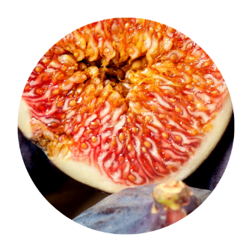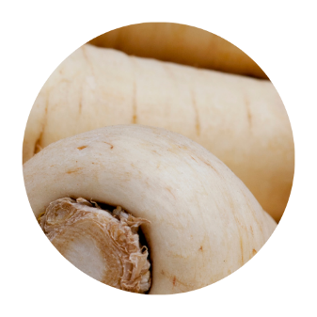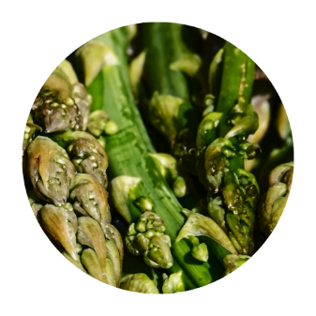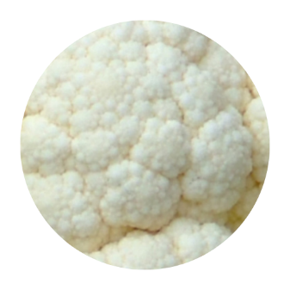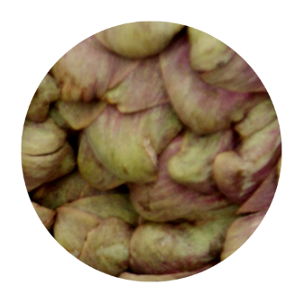



1. Name these vegetables.

