Corps Leader/ Safeguarding Lead
Name | Click or tap here to enter text.
Telephone | Click or tap here to enter text.
Email | Click or tap here to enter text.@salvationarmy.org.uk

Divisional Headquarters
Name | Click or tap here to enter text.
Role | Click or tap here to enter text.
Telephone | Click or tap here to enter text.
Email | Click or tap here to enter text. @salvationarmy.org.uk

Safeguarding Department - Territorial Headquarters
Telephone | 020 7367 4767
Email | safeguarding@salvationarmy.org.uk

Emergency Contacts
Police | 999 (101 non-emergency)
Local authority safeguarding
Children | Click or tap here to enter text.
Children out of hours | Click or tap here to enter text.
Adults | Click or tap here to enter text.
Adults out of hours | Click or tap here to enter text.

Helplines
Childline | Hourglass  (Action on Elder Abuse) | National Domestic Abuse Helpline | Respect  Men’s Advice Line (Domestic Abuse)
0800 1111 | 0808 808 8141 | 0808 2000 247 | 0808 8010327
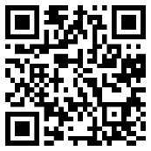 | 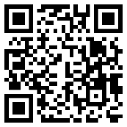 | 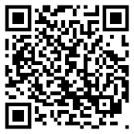 | 