Break Ground, Bring Hope -
Small Group Reflections
In addition to the sermon outline
(found at salvationist.org.uk/resources/key-dates/covenantsunday2026),
this resource contains reflective questions to be explored in a small group setting. As we look to break ground and bring hope this year, this material will help to begin this journey together and make space to process all it entails as we continue in our courageous discipleship. Adapt the content to meet the needs of your small group.

Scripture Reflections:
Read 2 Timothy 1:6-10 in different versions.

What inspires, intrigues, irritates or interests you?

Discipleship takes courage. As Paul writes in 2 Timothy 1:7, God gives us a spirit of power, love and self-discipline – not timidity. True discipleship is Spirit-empowered boldness shaped by Jesus, focused on growth and transformation. When it becomes timid, it risks turning inward – choosing maintenance over mission and belief over action.

What fears or hesitations might hold people back from bold obedience?

As we move from Step Up, Stand Out to Break Ground, Bring Hope, as a Covenant theme, where is God inviting us to be courageous and dig deeper, clear away resistance, and make space for renewal in our lives, relationships or community?

Read around Colossians 1:27, 1 Peter 1:3 and Exodus 34:6–7.

What do you notice, or feel God saying through these Scriptures?

Colossians 1:27 declares, ‘Christ in you, the hope of glory’, revealing the foundation of Christian hope as a deep recognition of his living presence within us. This hope is rooted in God’s character, as seen in Exodus 34:6–7 where he reveals his glory through compassion, grace, patience, abundant love and faithfulness – qualities that offer hope
not only to us but also through us to the world. Peter describes it as a ‘living hope’ in 1 Peter 1:3, born through the resurrection of Jesus Christ – a hope that renews, sustains and transforms.
Where might God be inviting us to break new ground, relationally, spiritually or missionally, so that living hope can bring light and restoration to others?

Creative Reflections:

Spend time reflecting as a group on this picture and accompanying Scripture. This is the kind of ground that represents the unploughed soil Hosea refers to.

Read Hosea 10:12 in several translations and paraphrases and reflect on this image.

Discuss: What differences in interpretation or emphasis do you notice? Which version speaks most deeply to you, and why?

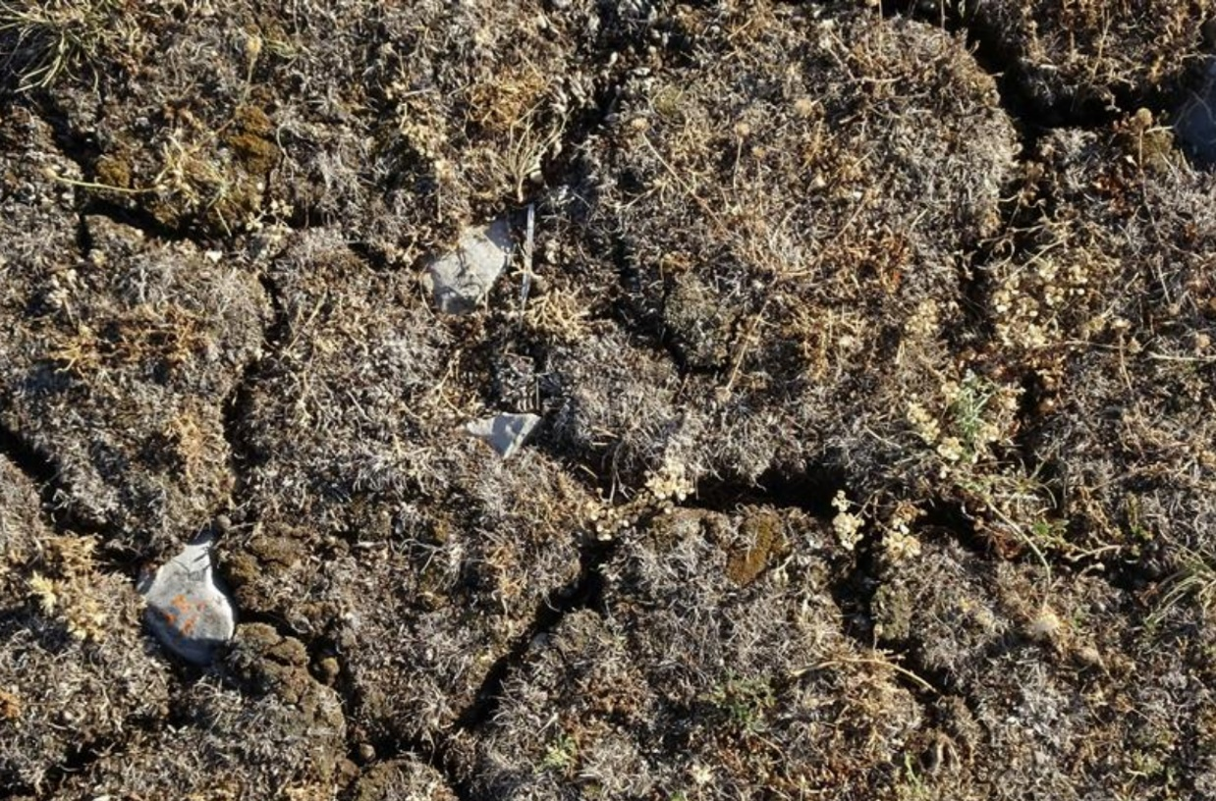

You may want to individually reflect on these questions along with some background music, allowing God space to stir hearts; or allow open space for people to discuss if they wish to.

- How does this image speak to you?
- What unploughed ground is God stirring you to address? What in your heart and life may God be asking you to remove, to make way for the ‘ploughing’?
- What does it look like to sow righteousness for yourself?

Today, agriculture is highly mechanised. Farmers use GPS-guided tractors, automated ploughs and soil sensors to prepare fields. But ancient farmers would have used simple wooden ploughs, often pulled by oxen or donkeys, sometimes tipped with bronze or iron for durability. Preparing the field involved removing large rocks that could obstruct ploughing or hinder seed growth. Labourers walked the fields, lifting or prying out stones and stacking them along the edges.

Discuss: What areas of the heart or habits could feel like ‘unploughed ground’, and how might facing them with courage lead to deeper spiritual clarity and renewal?

In the ancient Near East, farmers waited in hope for seasonal rains. Hosea 10:12 evokes this trust, God ‘showering his righteousness’ like rain on dry soil. This is active hope: seeking God with expectation, believing transformation will follow. Breaking ground becomes the way to renewal, within and beyond us.

Discuss: How does the image of God ‘showering his righteousness’ like rain on dry soil invite a trust in his timing and provision?

Quotation Reflections:

‘A farmer is helpless to grow grain; all he can do is provide the right conditions for the growing of grain. He cultivates the ground, he plants the seed, he waters the plants, and then the natural forces of the earth take over and up comes the grain …. This is the way it is with the Spiritual Disciplines – they are a way of sowing to the Spirit …. By themselves the Spiritual Disciplines can do nothing; they can only get us to the place where something can be done.’
- Richard J Foster, Celebration of Discipline

How does Richard Foster’s quote help us understand what it means to break up unploughed ground and wait faithfully for God’s transforming work?

‘Grace is not opposed to effort. It is opposed to earning. Effort is action. Earning is attitude.’
- Dallas Willard

How does understanding that grace is ‘not opposed to effort, but is opposed to earning’ reshape the way I approach spiritual disciplines and growth?

Application:

Discuss these final reflection questions together:

What is one area of my life, spiritually, relationally or missionally, where I sense God inviting me to break new ground and trust him more deeply?

How can I carry the hope of Christ into my everyday interactions, becoming a source of light and restoration in the places I live and serve?

Spend some time in prayer together. Depending on the relationships and discipleship journey of your small group, guide what feels like the appropriate time of prayer. Below are some suggestions for this time:

- People may have shared the ‘hardened ground’ in their hearts and lives. Pray into this together, invite God into those areas and ask him to soften hearts.
- Pray for your communities and the surrounding needs to which you can bring hope as a small group.
- Pray for those who are struggling to hold hope for themselves. Pray that God meets them in their need and helps to anchor them in his promises and faithfulness during the waiting seasons.
- Pray for God to embolden people with courage to continue this journey.

May you go with courage, ready to break new ground within your heart, your relationships and your community. May the Spirit guide you as you clear away what hinders growth, making space for God’s transforming presence. May you be rooted in living hope, carrying Christ’s love into the broken places of the world. And may you reflect his light and restoration within you, among you, and through you wherever he leads.

