GOOD FRUITS

SPECIAL DAYS

PREPARATION

- Prepare ingredients for a fruit salad for the group plus bowls and cutlery.
- Cut out the leaf templates and source colouring pens, string/ribbon and glue / sticky tape plus a tree/plant or image of a tree to hang the leaves on
- Create space for a large mural, cut out the fruit shapes and provide pens and glue
- Prepare a chocolate fountain / chocolate dipping pots / chocolate sauce, nine different fruits in labelled bowls plus bowls, cutlery or kebab sticks – and don’t forget napkins!
- Prepare to play the song ‘Fruit of the Spirit’, lyric video by Darren Winfield

Additional resources
- Leaf templates
- Fruit shapes

Please be aware of allergies.

INTRODUCTION/BACKGROUND

Pentecost celebrates the day that the Holy Spirit was given to the Church, as recorded in Acts 2:1-42. The Spirit descended like wind and fire and rested on the apostles’ heads – an amazing experience. However, on Pentecost it is just as important for us to celebrate the fruit of the Spirit – the love, joy, peace, patience, kindness, goodness, faithfulness, gentleness and self-control that come to us as God’s grace in our lives (Galatians 5:22-23). These are just as remarkable as any gifts of the Spirit that may be seen as more spectacular, and they speak the language of the Spirit just as powerfully.

This session challenges us to be ‘good fruits’ of the Holy Spirit that advance not only the work of the local corps/church, but also the Kingdom of God – God’s justice, peace and reconciliation in our world. When the Holy Spirit is stirring in us and shaping our thoughts, character and actions, we cannot help but have this ‘good’ love, joy, peace, patience, kindness, goodness, faithfulness, gentleness and self-control that appear and grow into more substantial fruit.

ACTIVITIES

FRUIT SALAD
Prepare and bring fruit to create a fruit salad that can be shared and eaten together. Perhaps bring a mix of traditional and more unusual fruit for members to try. Encourage members to share how they make their own fruit salad or if they have a favourite fruit combo – or are they a fan of the glacé cherry, often found in tinned fruit salads!

Thought
As you taste our fruit salad, do you note when it is soft, tangy, sweet or crunchy? Each fruit contributes to making the fruit salad better, just as our own uniqueness helps us to enrich our own community.

DISCUSS
Discuss with the group the nine fruit of the Spirit, eg:

- When have you seen an example of …?
- What difference did this fruit of the Spirit make?
- What other positive traits do you want to see in your group/corps/church?
- What would it be like if there was more … in the world?

Give each member a cutout leaf from the Leaf template – either one with a fruit of the Spirit or a blank one. Ask them to colour it in or create their own version with another positive trait they wish to see more of. Attach each leaf to a piece of string/ribbon and hang on a tree or stick to a tree image.

REFLECTION
Create a time of reflection, perhaps with some reflective music eg ‘Holy Spirit Wind’ by Dan Musselmann (2:00:17). Ask each member to select a fruit shape. On their shape ask them to write their names and what fruit of the Holy Spirit they wish to grow. Afterwards members can attach their fruit to a large mural and finish with a prayer, perhaps while listening to ‘Fruit of the Spirit’.

- ‘Fruit of the Spirit’
Lyric video by Darren Winfield (2:27)

ENJOY
Prepare nine fruits and decide with the group which fruit represents a fruit of the Spirit, eg:

- strawberries – love
- bananas – peace
- pineapple – self-control

Label the fruit bowls with their corresponding fruit of the Spirit and encourage members to make a fruit bowl or a fruit kebab with the fruit. Pour on or dip the fruit into chocolate sauce and enjoy eating it together.

Thought
As we enjoy this sweet goodness, remember Jesus can be seen as the ‘chocolate’ that flows all over all our behaviour, character and presence in our communities.

BIBLE READING/THOUGHT

Which fruit looks more appealing to you in a supermarket? Good fruit, right?

Unfortunately, no one can produce good spiritual fruit on their own. The good fruit of the Holy Spirit that we celebrate at Pentecost is found in a believer’s life. If you do not know the fruit of the Spirit, no worries; we will take this journey together. The apostle Paul lists nine of them:

‘But the fruit of the spirit is love, joy, peace, forbearance [patience], kindness, goodness, faithfulness, gentleness and self-control.’
(Galatians 5:22–23)

It is an impressive list, isn’t it? If you were expecting a fresh fruit salad, then you might be a little disappointed at first. But in the end who can argue against a little more love or joy or kindness in our world?

The ‘good fruit’ given at Pentecost through the coming of the Holy Spirit are the spiritual markers that every believer should display in some way as evidence of the change that the Holy Spirit is working in them. The writer Paul’s intent here was to remind the believers in the church in Galatia that when the Spirit is at work in work in their lives, it will be evident.

That’s not to say that we never struggle in any of these ways; that’s just not reality, is it? The good Lord knows that we struggle in more than a few of these ways on a daily basis. But we can also know that he is continuing a work in us each day.

The point is to do a little bit of self-examination. Are you bearing good fruit? Is your life evidence of the Pentecost power working within you? The fruit is the overflow of the Spirit working in our life. It is evidence of a life devoted to God, and it is integral to our relationships with the people in our lives.

Let us encourage each other so we can become good at is this. Seeing the ‘good fruit’ in each other and encouraging will help us all grow good fruit. It works. We can see it all around us if we try.

For example: (Feel free to personalise to your situation)

- Faithfulness in leaders and neighbours who visit or drop off food to a lonely neighbour.
- Kindness as people ring up a neighbour whose family member is in hospital, checking to see all is OK.
- Patience as a leader leads a small group discussion with someone who always tends to dominate the conversation.
- Self-control from a church leader with a persistent group of young people disrupting the youth club.
- Gentleness while visiting a man bereaved of his wife and whose grandchildren hold him close.

This is the kind of refreshing talk that propels us forward, calling out the ‘good fruit’ in each other.

The story of Pentecost can come across as something of a movie, big on special effects. Suddenly, there is a noise like the wind that fills the house where the disciples are hiding, and the Holy appears to them like tongues of fire which rest on each of them. Filled with the Holy Spirit, the disciples then run out into the streets and begin preaching.

We’re not likely to see a tongue of flame over anyone’s head nowadays. But if we can be the very best ‘good fruit’ in our communities and if we are living as Jesus taught, then we can love and be joyful, we can be peaceful and patient, we should be kind and generous, and we can aspire to be faithful, gentle and show self-control.

SONGS

- ‘Fruit of the Spirit’
Children’s lyric video by Brentwood Benson (3:12)

- SASB 250 ‘Colours of day [light up the fire]’
Lyric video by Divine Hymns (2:54)
Lyric video by Derri Daugherty, uploaded by Jonathan Priday (2:52)

- SASB 300 ‘Gracious Spirit, dwell with me’
Piano instrumental lyric video (tune: Ratisbon) by raszmies (2:36)
Lyric video (tune: Dix) by GCI Auckland (2:46)

- SASB 305 ‘Now the fruit of the Spirit is patience’
Video feat songsters (no lyrics) by Music & More (1:42)
Brass instrumental lyric video arr. Kevin Larsson by Stotfold Salvation Army (2:44)

WEBSITE AND CONTACT DETAILS

- Connect website: www.salvationarmy.org.uk/connect
- Family Ministries website: www.salvationarmy.org.uk/families
- Emails: familyministries@salvationarmy.org.uk
- Facebook: @sarmyfm
- Twitter: @ukifamily
- Instagram: safamily_ministries


LEAF TEMPLATES





















FRUIT SHAPES










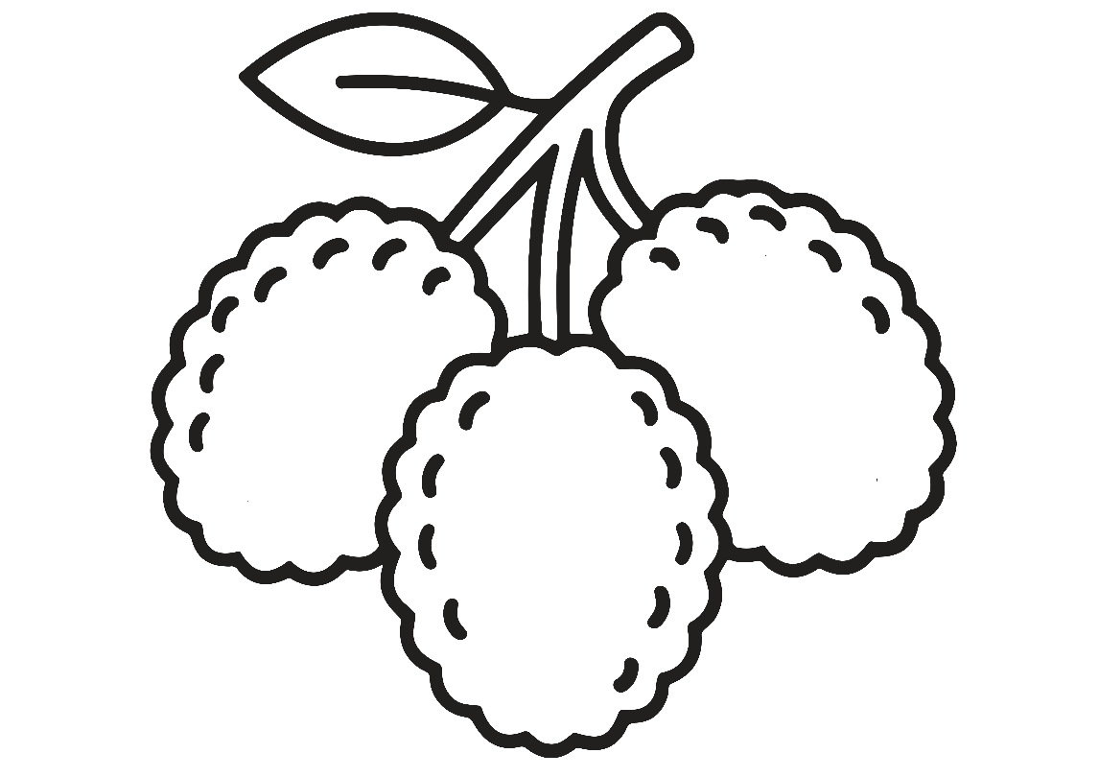

z\







