PALM SUNDAY PRAISE

SPECIAL DAYS

PREPARATION

- Invite two members to prepare to read the two Bible readings for the beginning of the Bible Reading / Thought
- Prepare for a game of Pin-the-tail-on-the-donkey: a large picture of donkey (printed or roughly drawn); a blindfold; a cut-out tail and drawing pin
- Make some Pax cakes to enjoy together – see recipe below

Additional resources
- Pin-the-tail-on-the-donkey (enlarge to use)
- Pax cake recipe

Please be aware of allergies.

INTRODUCTION/BACKGROUND

Today we will consider the meaning of Palm Sunday and remember the events that took place that day as recounted in the Bible.

During the 16th Century in England, Pax cakes began to be handed out by churches to the congregation after the Palm Sunday service. In some areas they were stamped with an image of the lamb and flag. The cakes were a reminder that people should come together in peace – pax is the Latin word for peace – as they approached the events of Easter.

ACTIVITIES

PLAY
Play the game ‘Pin-the-tail-on-the-donkey’ as a fun ice-breaker and introduction to the Palm Sunday story and session.

DISCUSS
Discuss large events that members have attended or watched on TV. Ask what emotions and feelings they felt being at such a huge event.

SHARE
Enjoy eating the Pax cakes together.

BIBLE READING/THOUGHT

Zechariah 9:9

Matthew 21:1-11

Can you recall when you were last part of a large crowd, cheering and waving at a large event? The excitement, the straining to get to the front of the crowd! Nowadays there would be people with their mobile phones ready to take photos and videos of the event. Possibly today we are more content to watch large events on the TV or online in the comfort of our armchairs with a cup of tea or coffee.

There were no such options on that first Palm Sunday for the crowds of Jewish people that had travelled to Jerusalem to celebrate the Passover. John 12:12 and 13 tells us that the crowd had heard that Jesus would be entering Jerusalem, just as the prophet Zechariah had told them. They gathered to greet him, laying their cloaks for him to travel over and waving palm branches. They treated him as the King and Messiah they were expecting, because they’d heard of the miracles he was performing and how amazing his teaching was.

I wonder if the owner of the donkey was in the crowd? If so, maybe he pushed his way forward and excitedly told anybody who would listen, ‘That’s my donkey!’ His moment of fame! His voice would probably have been drowned out by the cries of ‘Hosanna!’ as the crowd surged around Jesus, their Messiah, their King.

We know the crowd were enthusiastic that day, believing they were witnessing a ‘winner’ in Jesus … just as football crowds cheer their winning team when it is scoring goals. But listen to their comments afterwards if their team loses. Very much like the Palm Sunday crowd, their cheering is so quickly forgotten in the following days.

This crowd, probably made up of pilgrims to Jerusalem, then encountered the city authorities who felt differently about Jesus; they were angered and threatened by him, and wanting to get rid of him. Faced with their power, the crowd later turned against Jesus and changed their shouts of ‘Hosanna!’ to calls to ‘Crucify him!’
Palm Sunday presents us with a challenge to be disciples, followers of Jesus, in whatever circumstances and at whatever cost. Not only when life is going well and faith feels easy, but also in those times when our faith is challenged, and following Jesus is costly.

REFLECTION
Share the song SASB 649 ‘If crosses come’. Invite members to reflect on their commitment to Jesus in all circumstances of life.

- SASB 649 ‘If crosses come (I’ll not turn back)’
Lyric video by mbellshaw (4:49)
Duet piano lyric video by The Salvation Army Oshawa Church (4:25)

‘Let nothing disturb you.
Let nothing frighten you.
Though all things pass,
God alone never changes.
Patience wins all things.
If you have God, you will want for nothing.
God alone suffices.’
Teresa of Ávila

SONGS

- SASB 366 ‘Hosanna, hosanna, hosanna in the highest’
Congregational lyric video feat footage from the 2018 Palm Sunday procession from Bethphage to Jerusalem by Chet Valley Hymns and Songs (2:54)
Brass instrumental lyric video by Salvation Army Video Songbook – Kelston Stanford (1:13)

- SASB 362 ‘Give me joy in my heart’
Brass instrumental lyric video by Salvation Army Video Songbook – Kelston Stanford (1:48)
Live performance video (press cc for lyrics) by Elle Limebear (2:18)

- SASB 236 ‘All hail the Lamb’
Brass instrumental video by Salvation Army Video Songbook – Kelston Stanford (1:46)
Lyric video feat Robin Mark by Video Praise 1865 (2:35)

- ‘Hosanna – Praise is rising’
Lyric video by Maranatha! Music (4:48)
Lyric video by Paul Baloche Leadworship (6:53)

WEBSITE AND CONTACT DETAILS

- Connect website: www.salvationarmy.org.uk/connect
- Family Ministries website: www.salvationarmy.org.uk/families
- Emails: familyministries@salvationarmy.org.uk
- Facebook: @sarmyfm
- Twitter: @ukifamily
- Instagram: safamily_ministries
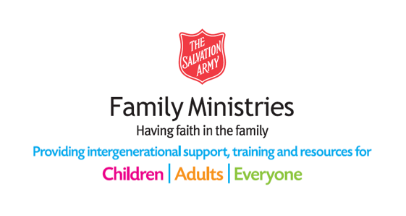

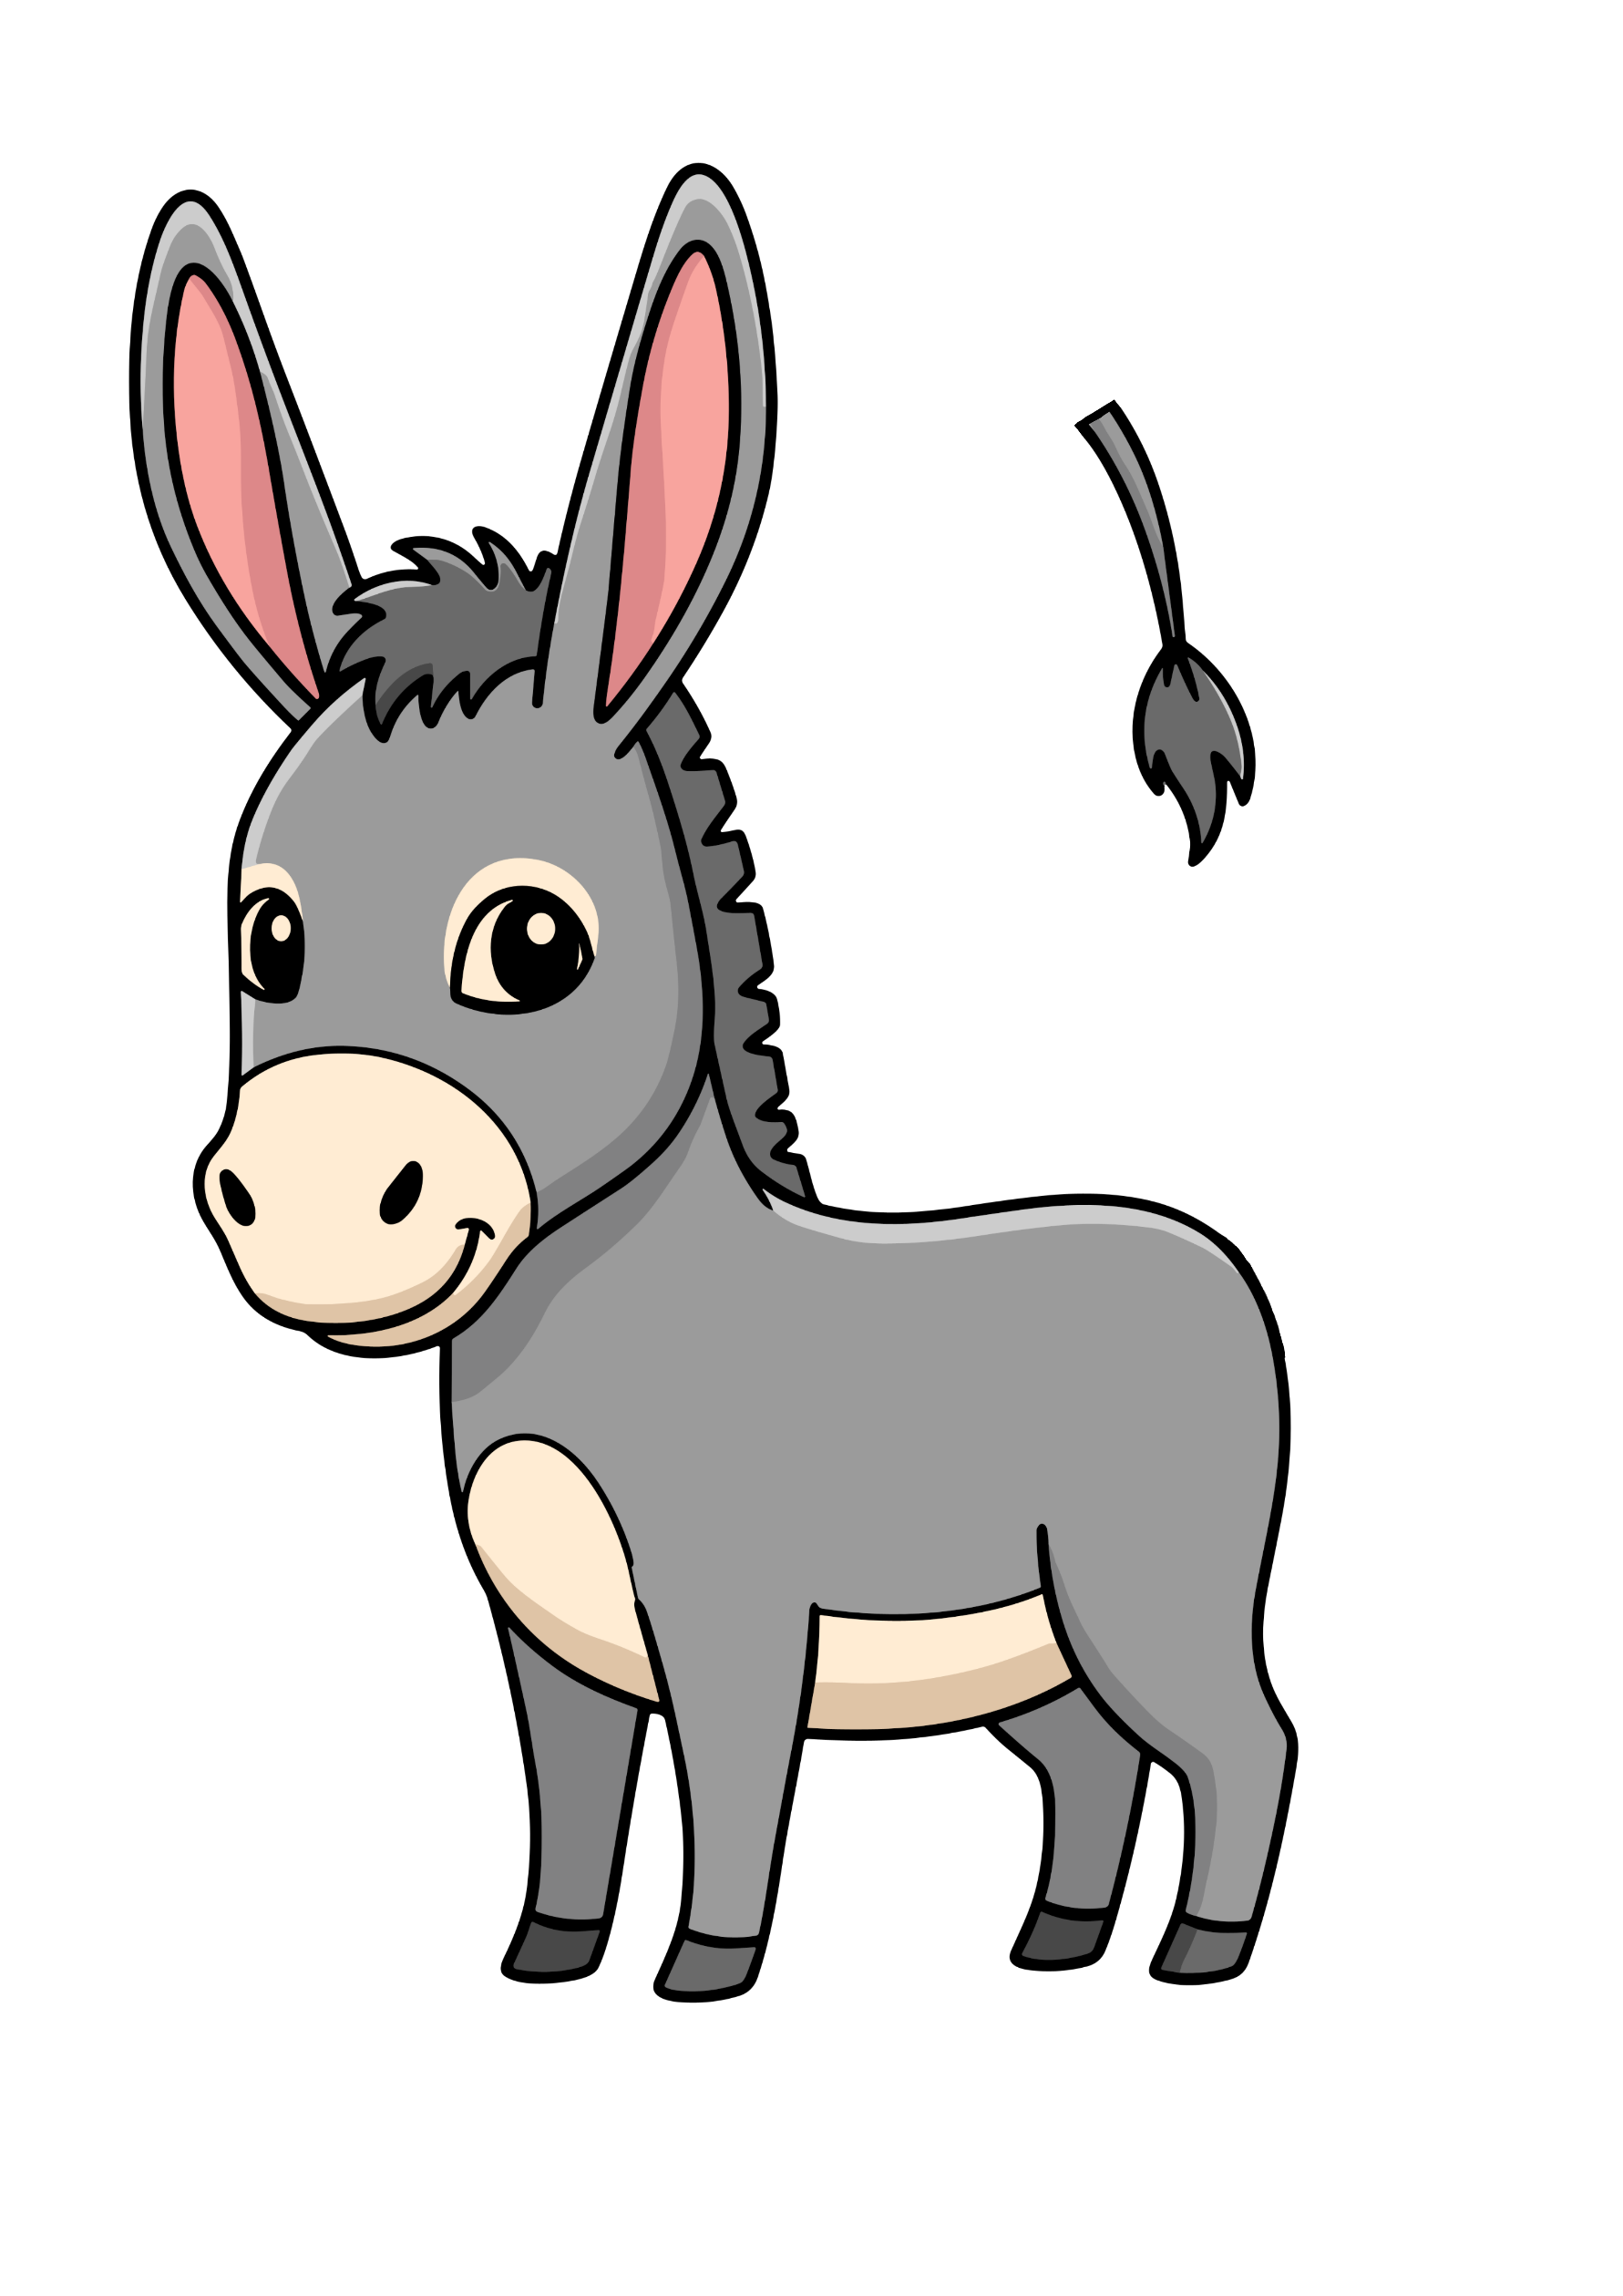
PIN-THE-TAIL-ON-THE-DONKEY

PAX CAKES

(makes approx 50 cakes)
- 1 egg
- 1 cup of sour milk or buttermilk
- 2 tablespoons of vegetable oil
- 1 cup white flour
- 1 tablespoon sugar
- 1 teaspoon sugar
- 1 teaspoon baking powder
- ½ teaspoon baking soda
- ½ teaspoon salt

Optional – you may wish to ice the word ‘Pax’ on to the cakes.

INSTRUCTIONS
- Beat the egg

- Add all the other ingredients and beat until smooth

- Grease heated skillet or griddle

- Pour the batter on to hot griddle in ‘scone’ size dollops

- Turn Pax cakes when bubbles start to show

- Fry on second side until brown

- Sprinkle with icing sugar

