WHAT MATTERS MOST?

PSALMS

PREPARATION

- Make a set of six cards from the What matters sheet for each member and provide writing pens
- Print Psalm 100:1 colouring sheets and gather a range of colouring pens/pencils and/or paper
- Be prepared to source and play various worship songs, depending on what members choose

Additional resources
- What matters
- Psalm 100:1

INTRODUCTION/BACKGROUND

What matters most to you? What do you value the most in life?

Perhaps you’re a huge football fan, or you just couldn’t be without your pet, or your family photos are your prized possession.

God asks us to place him first in our heart and in our life. We, as Christians, are called to worship God, but what does worship mean and how can we make sure that we are true worshippers?

ACTIVITIES

SHARE

Give each member a set of six cards made from the What matters sheet. Ask them to complete the phrase on each card – or only some of them if they prefer. Once completed, ask each member to rank the cards in order of importance to them.

Discuss the following questions, as a group or with a partner:

- What is the one thing you just couldn’t do without?
- How does your card order compare to someone else’s?
- How does it differ?
- Would you change the order that they have put things in?

COLOUR
- ‘Shout for joy to the Lord, all the earth.’

Give members the Psalm 100:1 colouring sheet or provide resources so they can create their own artwork based on the psalm. Create a time of reflection as members consider what the verse means to them.

Thought

This uplifting verse calls us to joyful worship, to give thanks, and to draw our attention back to God as the centre of our lives.

SING

Ask members to nominate their favourite worship song and choose to listen to or sing along with a verse of each, with accompaniment or online videos if possible.

BIBLE READING/THOUGHT

Psalm 100
To worship something or someone is to demonstrate their immense worth to you. When we are devoted, adoring, respectful and loving to that thing or person, it is a mark of how we value them or it.

When someone is so devoted to their favourite football team that they adorn their car window with a team sticker, their favourite mug has the club’s name on it, their front door is painted in team colours and they devote every Saturday afternoon to attending matches, we might call them a fanatic. But we could just as easily call them a worshipper. They hold the club, the players and the manager (however briefly) in high esteem; the stadium is treated as hallowed ground.

When we consider what worshipping God really means, we can look to the Bible for guidance, and in particular to the Psalms. There are many examples in the book of Psalms about how to worship: we can be joyful (Psalm 95), reverent (Psalm 95) or grateful (Psalm 136) in our worship. We can play music (Psalm 150), sing new songs and dance (Psalm 149) and even worship in lament (Psalm 130). When we offer God our sincere thoughts and feelings and demonstrate his importance in our every situation then we are true worshippers.

Psalm 100 includes some pretty good guidelines for worship:

- ‘Shout for joy to the Lord, all the earth.’ (v1)
That means you, too!

- ‘Worship the Lord with gladness; come before him with joyful songs.’ (v2)
Joyful – not necessarily tuneful – songs!

- ‘Know that the Lord is God. It is he who made us, and we are his; we are his people, the sheep of his pasture.’ (v3)
Acknowledge his place in our lives.

- ‘Enter his gates with thanksgiving and his courts with praise; give thanks to him and praise his name.’ (v4)
Say thank you for all he has done.

- ‘For the Lord is good and his love endures for ever; his faithfulness continues through all generations.’ (v5)
Stand in awe of the Almighty.

So, are you a true worshipper? Here’s your opportunity to worship according to David’s plan in Psalm 100.

- Step 1: Come together with other worshippers.
You’re here, aren’t you?

- Step 2: Sing a song of praise with gusto.
Even if you’re not the best singer!

- Step 3: Speak aloud what God means to you.
(Ask group members to do so.)

- Step 4: Thank him for something that he has done for you.
(You could do this quietly, shout them out or make a list.)

- Step 5: Stop for a moment and consider the wonder of the Lord:
- His power
- His creation
- His gift of his son, Jesus
- His love that conquers the grave
- His faithfulness through all generations
(Pause for quiet reflection.)

PRAYER
Father God,
Today we gather as a group of your people, and we join with all creation in honouring you.
We acknowledge that you and you alone are worthy of all praise.
You are far more important than a prized possession, a family photo, a favourite hobby, or a football club.
We thank you for who you are.
We praise you because you are good beyond all our understanding.
We trust you for all that is to come.
Thank you, Lord.
Amen.

SONGS

- SASB 64 ‘The splendour of the King, clothed in majesty (How great is our God)’
Lyric video feat William Booth College from BBC’s Songs of Praise uploaded by js 12345 (3:06)
Official lyric video feat Chris Tomlin (4:26)
Brass and vocal video (press cc for lyrics) by Salvation Army Music Index (3:13)

- SASB 114 ‘Light of the World (Here I am to worship)’
Official lyric video by Integrity Worship (4:42)
Live performance lyric video feat Tim Hughes by Mission Worship (5:38)
Brass instrumental lyric video by Stotfold Salvation Army (2:46)
Lyric video by Ottawa Citadel Worship Team uploaded by John van Gulik (3:02)

- SASB 343 ‘O worship the Lord in the beauty of holiness’
Congregational lyric video by Chet Valley Hymns and Songs (3:23)

- ‘Goodness of God’
Lyric video feat Bethel Music by music meets heaven (5:03)
Official lyric video by CeCe Winans (4:57)
Official live video (press cc for lyrics) by Israel & New Breed (11:26)
Brass instrumental lyric video (to listen to!) feat The International Staff Band by Salvation Army Music (4:43)

WEBSITE AND CONTACT DETAILS

- Connect website: www.salvationarmy.org.uk/connect
- Family Ministries website: www.salvationarmy.org.uk/families
- Emails: familyministries@salvationarmy.org.uk
- Facebook: @sarmyfm
- Twitter: @ukifamily
- Instagram: safamily_ministries
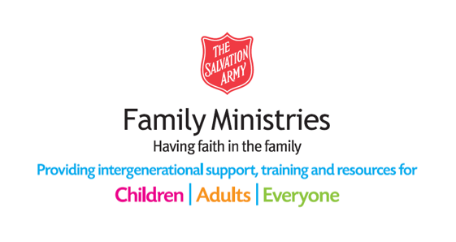

WHAT MATTERS

What is … your most prized  possession? | What is … your favourite  hobby?
What is … your tribe?  eg football club / social group / nationality  / clan | What is … your favourite celeb?  eg singer / musician / film star
What is … your church? | What is … your favourite film /  TV show?

PSALM 100:1
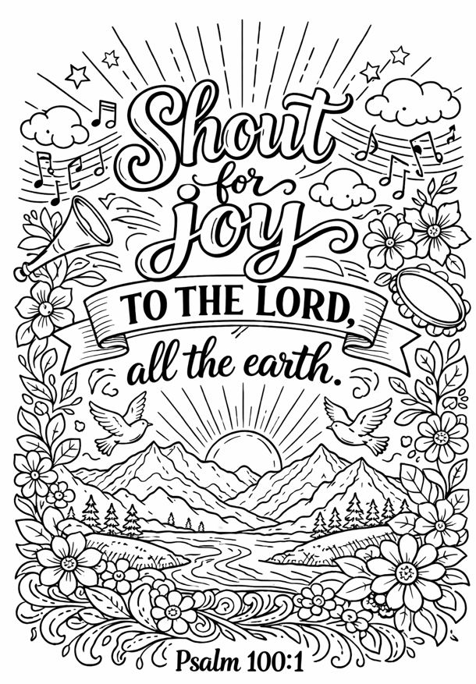

Image generated with the help of AI.

