GOD’S KINGSHIP

PSALMS

PREPARATION

- Ask members to bring any royalty memorabilia, eg coronation mugs, spoons, tea towels …
- Arrange a paper crown for each member (eg from Amazon) and a fake sword like a pool noodle or foam sword (eg from Amazon or Theworks.com)
- Provide ingredients and equipment to make coronation chicken sandwiches

Recipe and alternative versions by fellybull.com

Vegetarian version by goodfood.com
- Source cupcakes, icing ingredients to make royal baby cupcakes inspired from wearetateandlylesugars.com
- Gather resources to make a royal sceptre: styrofoam ball, purple paint, bubble tea straw, washi tape, decorations, ribbon and glue
- Organise a royally themed quiz

Kings and queens online quiz by English-heritage.org.uk

print copies of the Bible kings and queens quiz and provide copies of the Bible (optional)
- Prepare for a game of Pin the crown (Blu-tak and/or pins)

Enlarge and print the Pin the crown sheet

Purchase a copy eg from ebay.co.uk
- Create a list of members of royalty – current, historical and biblical – and have sticky notes and pens

Additional resources
- Bible kings and queens quiz
- Pin the crown game

Please be aware of allergies.

INTRODUCTION/BACKGROUND

When you hear the word ‘king’ or ‘queen’ what comes to mind? Perhaps the words include wealth, privilege – perhaps even celebrity! The ideas we have about royalty often come from the photographs and videos we see of royal families all over the world. People who are treated with awe and respect; who represent a nation or a tribe of people.

In biblical times, kingship was more than gathering wealth and prestige; it was about stewardship, responsibility and wisdom. We are told that despite the many kings and queens we read about in the Old Testament particularly, there were very few that chose to follow God’s leading and there were only a minority that God was truly pleased with.

Under the leadership of the wisest kings and queens, the Israelite kingdoms flourished. However, royal leaders who rejected God and his sovereignty often led their nation to reject God’s ways. Time and time again, God had to call the people back into a relationship with him – usually through the prophets. We are told of kings such as David and Solomon who were wise and righteous – although even they rejected God at times to follow their own way, and they faced the consequences of their actions.

Today, as we consider Psalm 93, we see that the ultimate sovereignty comes from God, and it is under his control and leading that nations thrive best. We pause to consider today that he is the only one truly worthy of our awe and spiritual respect and majesty belongs to him alone.

ACTIVITIES

DISCUSS
Ask members to share their royalty memorabilia and any stories they have attached with it.

- Where were you during royal weddings/funerals/coronations?
- Do you have any memories of any other royal events? Were you involved in any way?
- Have you met any royalty? What happened? What were your impressions of them?

Watch the clip of Queen Elizabeth II talking about the Imperial state crown.

The Queen’s advice on wearing a crown by BBC News (1:28)

- What do you think is the best and worst thing about being an earthly king or queen and why?
- What do you think is the most important responsibility of wearing the crown?

QUIZ
Do a quiz based on kings and queens.

- Kings and queens quiz by English-heritage.org.uk
Adapt this online quiz about Kings and Queens of England to suit your group.
- Bible kings and queens quiz
Print and play this multiple-choice quiz in groups, pairs or individuals. Provide Bibles to look up, if you wish to make this a search style of quiz.

GAME
Play a game of Knock the crown off. Give each player a paper crown and a pool noodle or something similar to use as a ‘sword’. Everyone places the crown on their own head securely. The idea is that once the leader shouts ‘go’, all members aim to knock off each other’s crowns while still trying to keep hold of their own crown. The winner is the last person with their crown remaining on their head.

Please be safety aware – especially of eyes and glasses.

RECIPES

Coronation chicken
The coronation chicken recipe was created to honour Queen Elizabeth II’s coronation in 1953. Since then we have had the jubilee chicken (2002), the platinum pudding (2022) and the coronation quiche (2023). What do members think the next recipe will be?

Make some coronation chicken sandwiches together and share them around.

- Recipe and alternative versions by fellybull.com
- Vegetarian version by bbcgoodfood.com

Decorate
Decorate some ‘royal baby’ cupcakes using homemade or readymade cupcakes.
Decorating tips from wearetateandlylesugars.com

Thought
When babies are born into royal families, they are not aware of the duties, expectations and obligations they might have to take on in later life. Spend time, while decorating, to reflect on the role and responsibilities baby Jesus was born into. How is Jesus’ kingship different from what we normally expect from a king?

Please be aware of allergies.

CRAFT
Make a royal sceptre from woojr.com. You may wish to paint the foam balls in advance as they take time to dry.

Thought
There are many symbols of royal power, like sceptres, crowns and orbs. But Jesus needed none of these. How do we recognise his kingship today?

GAMES
Have fun playing some games with a royal theme.

Pin the crown
Find out who can stick the crown closest to the king’s head. Enlarge and print the Pin the crown sheet or purchase one eg from ebay.co.uk.

Who am I?
Give each member a sticky note with the name of a member of royalty – it can be current, historical or biblical. Stick the note on their forehead so they can’t see who they have. Each member takes it in turns to ask a question that needs a ‘yes’ or ‘no’ answer, to identify who is written on their sticky note. The winner is the person who identifies their person first. Eg:

Current: King Charles III, Queen Camilla, Prince William, Princess Anne, Prince
George
Historical: King Henry VIII, Mary Queen of Scots, King George VI, Queen Cleopatra, Queen Marie-Antoinette, Queen Victoria
Biblical: King David, King Solomon, Queen Esther, King Herod, Pharoah

BIBLE READING/THOUGHT

Psalm 93
This psalm is a reminder that Jesus is always on the throne no matter what the circumstances. We face a lot of uncertainty these days – there are people letting us down, people being forced to resign because of inappropriate behaviour. There is little feeling of permanence in our world except for hateful things – or so it can seem.

Right at the beginning of this short psalm, we are certain of where God is placed.

- ‘Our Lord, you are King!
Majesty and power are your royal robes.
You put the world in place, and it will never be moved.
You have always ruled, and you are eternal.’
(Psalm 93:1-2 CEV)

There are certain things that earthly kings and queens and the spiritual kingdom have in common. Most kings are clothed in royal robes, and verse one tells us this is so with God. Most earthly kings have a measure of power in their reign, and so it is with God except his is an omnipotence that cannot be equalled. There may be several other parallels too, but if we examine the psalm carefully we note there are many things that set the Almighty Sovereign God apart from every other king.

The fact that God established the world gives him a fundamental insight into how it should be ruled in ways that bring justice and wisdom to the people who live on earth. We are also told at the end of the psalm that God rules in truth and holiness. There is no one who lives that can compare to the holiness of the King of kings.

However respectful we may feel towards those who govern us and represent us in royal circles, none can ever be a match or be more deserving of our wonder, awe and praise than our Sovereign God. Next time you come before God, in your heart, bow before him with even greater reverence than you would any earthly king or queen, for he alone is truly worthy of our subservience, obedience and adulation.

PRAYER

King of kings, our Sovereign God, we bring our praise and our prayers to you in this hour.

Help us to give you the esteem you are due.

Thank you that no matter what storms we face in our lives, your place has always been and should forever be firmly upon the throne of our lives.

Be restored to your rightful place, we pray.

For your Kingdom’s sake. Amen.

SONGS

- SASB 358 ‘Crown him with many crowns’
Brass instrumental lyric video by Maidenhead Citadel Salvation Army (2:48)
Live performance video feat Chris Tomlin (press cc for lyrics) by Passion Music (5:14)
Official lyric video by Reawaken Hymns (4:22)

- SASB 376 ‘King of kings, majesty’
Brass instrumental lyric video by Salvation Army Songbook – Kelston Stanford (2:44)
Soloist lyric video by Plexus Resources (Salvation Army) (3:03)
Lyric video by The ALTAR (3:48)
Congregational lyric video by @gospelshow1 (3:38)

- SASB 382 ‘Majesty, worship his majesty’
Brass instrumental lyric video by Salvation Army Songbook – Kelston Stanford (1:25)
Lyric video by Classic Fox Worship (3:46)
Lyric video by Marantha! Music (4:49)

- SASB 204 ‘There is a Redeemer’
Brass instrumental lyric video by Salvation Army Songbook – Kelston Stanford (2:17)
Live gospel lyric video by The Glory Channel (4:11)
Lyric video by Bruce Hil Worship Lyrics (3:07)

- ‘King of my heart’ by Kutless
Lyric video by Landon’s lyric videos (4:11)

WEBSITE AND CONTACT DETAILS

- Connect website: www.salvationarmy.org.uk/connect
- Family Ministries website: www.salvationarmy.org.uk/families
- Emails: familyministries@salvationarmy.org.uk
- Facebook: @sarmyfm
- Twitter: @ukifamily
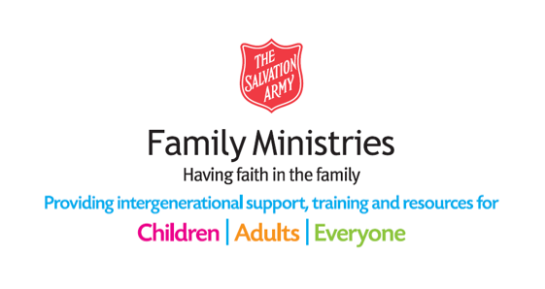
- Instagram: safamily_ministries

BIBLE KINGS AND QUEENS QUIZ

- Which king of Israel was more wicked than any before him?
- Abimelech
- Ahab
- Manasseh
- Menahem

- Which king was killed by his sons Adrammelek and Sharezer?
- Ahaz
- Jotham
- Manasseh
- Sennacherib

- Which queen was thrown from a window and then eaten by dogs?
- Athaliah
- Esther
- Jezebel
- Queen of Sheba

- Which king of Judah was overtaken by an invading army and had his eyes cut out?
- Abijah
- Jehoram
- Rehoboam
- Zedekiah

- Who was made king of Judah at seven years of age, after he had been in hiding for six years?
- Ahaz
- Hosea
- Jehoshaphat
- Joash

- Which queen tried to kill a whole royal family because her son had been killed?
- Athaliah
- Esther
- Jezebel
- Queen of Sheba

- Which king did God smite with leprosy?
- Amaziah
- Athaliah
- Jehoram
- Uzziah

- Which king of Israel followed heathen practices by burning his children in the fire?
- Abimalech
- Ahab
- Ahaz
- Menahem

- What name did God say to the prophet Nathan, to give baby Solomon?
- Joab
- Jedediah
- Jeremiah
- Nathan

- Which king was guilty of idolatry by making two golden calves and commanding the people to worship them?
- Jehu
- Jeroboam
- Joktan
- Joram

BIBLE KINGS AND QUEENS QUIZ – BIBLE SEARCH

1. Which king of Israel was more wicked than any before him? (1 Kings 16:29-30)
- Abimelech
- Ahab
- Manasseh
- Menahem

2. Which king was killed by his sons Adrammelek and Sharezer? (2 Kings 19:36-37)
- Ahaz
- Jotham
- Manasseh
- Sennacherib

3. Which queen was thrown from a window and then eaten by dogs? (2 Kings 9:30-36)
- Athaliah
- Esther
- Jezebel
- Queen of Sheba

4. Which king of Judah was overtaken by an invading army and had his eyes cut out? (2 Kings 25:7; Jeremiah 39:6-7)
- Abijah
- Jehoram
- Rehoboam
- Zedekiah

5.Who was made king of Judah at seven years of age, after he had been in hiding for six years? (2 Chronicles 22:11-12; 24:1)
- Ahaz
- Hosea
- Jehoshaphat
- Joash

6.Which queen tried to kill a whole royal family because her son had been killed? (2 Kings 11:1)
- Athaliah
- Esther
- Jezebel
- Queen of Sheba

7.Which king did God smite with leprosy? (2 Chronicles 26:19)
- Amaziah
- Athaliah
- Jehoram
- Uzziah

8.Which king of Israel followed heathen practices by burning his children in the fire? (2 Chronicles 28:1-3)
- Abimelech
- Ahab
- Ahaz
- Menahem

9.What name did God say to the prophet Nathan, to give baby Solomon? (2 Samuel 12:24-25)
- Joab
- Jedidiah
- Jeremiah
- Nathan

10.Which king was guilty of idolatry by making two golden calves and commanding the people to worship them? (1 Kings 12:26-28)
- Jehu
- Jeroboam
- Joktan
- Joram

BIBLE KINGS AND QUEENS QUIZ ANSWERS

1. Which king of Israel was more wicked than any before him?
- Abimelech
- Ahab (1 Kings 16:29-30)
- Manasseh
- Menahem

2.Which king was killed by his sons Adrammelek and Sharezer?
- Ahaz
- Jotham
- Manasseh
- Sennacherib (2 Kings 19:36-37)

3.Which Queen was thrown from a window and then eaten by dogs?
- Athaliah
- Esther
- Jezebel (2 Kings 9:30-36)
- Queen of Sheba

4.Which king of Judah was overtaken by an invading army and had his eyes cut out?
- Abijah
- Jehoram
- Rehoboam
- Zedekiah (2 Kings 25:7; Jeremiah 39:6-7)

5.Who was made king of Judah at seven years of age, after he had been in hiding for six years?
- Ahaz
- Hosea
- Jehoshaphat
- Joash (2 Chronicles 22:11-12; 24:1)

6.Which queen tried to kill a whole royal family because her son had been killed?
- Athaliah (2 Kings 11:1)
- Esther
- Jezebel
- Queen of Sheba

7.Which king did God smite with leprosy?
- Amaziah
- Athaliah
- Jehoram
- Uzziah (2 Chronicles 26:19)

8.Which king of Israel followed heathen practices by burning his children in the fire?
- Abimelech
- Ahab
- Ahaz (2 Chronicles 28:1-3)
- Menahem

9.What name did God say to the prophet Nathan, to give baby Solomon?
- Joab
- Jedidiah (2 Samuel 12:24-25)
- Jeremiah
- Nathan

10.Which king was guilty of idolatry by making two golden calves and commanding the people to worship them?
- Jehu
- Jeroboam (1 Kings 12:26-28)
- Joktan
- Joram

PIN THE CROWN
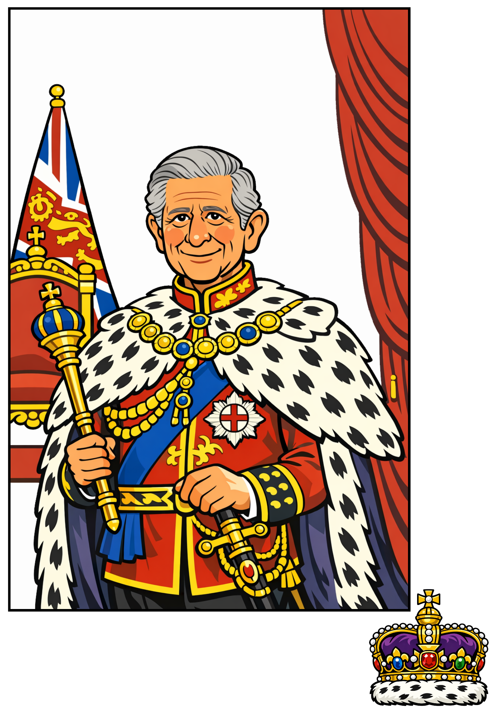

Images generated with the help of AI.

