TRUST AND FAITH

PSALMS

PREPARATION

- Ask a member to prepare to read the poem ‘I trust in Jesus’ by Michael P Johnson and print out a copy for each member
- Print out a range of different translations of Psalm 11 (eg from Biblegateway.com)
- Bake a Victoria sponge cake from a National Trust recipe (or provide a shop-bought one)
- Gather resources for a blind taste test, eg scarves for a blindfold, honey, chocolate, apple, mango, mayonnaise, cucumber – and more challenging ones, eg horseradish sauce, anchovies, piccalilli, Marmite, sriracha sauce, blue cheese (avoid nuts and other potential allergens)
- Provide clean, medium-sized smoothish stones and acrylic pens or paint
- Fill a pillowcase with roughly 20 different everyday objects

Additional resources
- I trust in Jesus poem

Please be aware of allergies.

INTRODUCTION/BACKGROUND

There are many different reasons why we trust others and have different levels of trust. Who we trust often depends on the relationship we have with them, the reputation they have and how important our safety is in their hands. It could be financial, emotional or practical. Who we trust can also depend on the competency and integrity of the other person and how reliable in the past they have been to show themselves worthy of that trust for the future.

Trust and faith often go hand in hand. Because we trust someone or something, we can put our faith in it going forward. Equally, if someone lets us down, that trust is fractured and we resist placing our faith in them for the future.

As Christians we recognise that we need to put our faith and trust in God. We can do this wholeheartedly, often because we know God has been faithful to us in the past. We can see that even though things have not always gone smoothly, the bigger picture testifies that God was in control all along, and we know that in all things God works for the good of those who love him. This is not always easy to see at the time, but we recognise that trusting is never something that is as simple as it sounds. It does, by its very nature, require faith.

Today we are looking at Psalm 11 and reminding ourselves that throughout all the changing seasons of life – despite whatever the world throws our way – God is secure and consistent in his faithfulness.

ACTIVITIES

DISCUSS
Think of as many different people you can that we put our trust in. What makes us fully trust someone?

POEM
Give each member a copy of the poem (selected verses) ‘I trust in Jesus’ by Michael P Johnson (poemhunter.com). Perhaps a member would read it out:

Discuss the poem together.

- Which line spoke to you and why?
- Is there a line you would add? I trust …
- What parts of God’s character and his actions do you find it easier or more difficult to trust and why?

Psalm 11
Some translations of Psalm 11 start with ‘a statement about trust in God’ – or something similar. Ask members to share what they think a psalm about trust in God might say.

Read though Psalm 11 in various translations.

- What surprises you in this psalm? What is expected?
- What does the psalm say to you?
- What are the common words that crop up?

TASTE
Provide some different ‘tastes’ for members to try. Don’t tell them what they are and see if they can guess. Put some ‘unusual’ ones in there. Who is brave enough to try them blindfolded? Warn members who have severe dietary requirements.

Afterwards share:

- What did it feel like to put your trust in someone knowing you may not like the result?
- Were there any tastes you were pleasantly surprised about?

BAKE
Why not bake and enjoy a Victoria sponge – perhaps using a National Trust recipe? This simple but yummy staple is an all-time classic.

Thought
Can you go wrong choosing a Victoria sponge? We have faith in the recipe and trust that the sponge will rise in the oven. Our previous knowledge will let us know to expect a light sponge and sweet raspberry jam. And we know from experience what it will be and that it will taste good.

That’s just like our faith in God. We have put our faith in him in the past and we know good things come from trusting him – and not just cake!

CRAFT
Design a ‘rock verse’ using a garden stone and acrylic paints. An example is shown below, but you can decorate however you prefer, eg with ‘Jesus is my rock’.

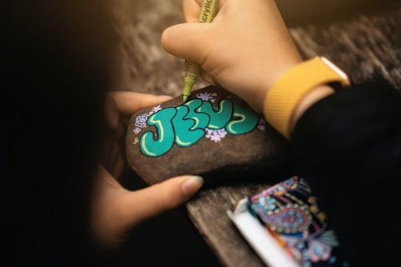Unsplash.com

Thought
Rocks are the foundation of many structures, like buildings and walls. Man has always used rocks, trusted rocks, to provide stability and protection. It is no wonder that the Old Testament describes God as a rock: ‘He is the Rock, his works are perfect, and all his ways are just’ (Deuteronomy 32:4).

In what ways do we choose to trust Jesus as our firm foundation?

GAME
Play a game of What’s in the pillowcase? Have items in a pillowcase and pass it around. Each member has to try and identify an everyday household item without being able to see what’s inside.

Thought
It’s not always easy to identify objects when we only use our sense of touch. We want to see, to validate it, with our own eyes. When do you find it hardest to trust when you don’t have all the facts? How does Psalm 11 encourage trust when life feels uncertain or shaky?

BIBLE READING/THOUGHT

Psalm 11
When we look around us today, it’s very easy to believe that never before has the world faced such catastrophes as we are seeing now: corruption in power; threats of nuclear war; economic downfall; climate crisis; people turning away from God. All these things can lead us to believe that our world is so far out of control that it cannot be rectified.

The truth is that throughout history, calamities, wars, illness and corruption have always featured, and there have been countless times when it has seemed that everyone is doomed. Bible times were no different. David faced all sorts of danger throughout his life. He found himself running away from tormentors or hiding in the wilderness or seeking solace because of his own mistakes – of which there were many. David often found himself in a situation where he had to choose between listening to the counsel of those around him – for example the prophet Nathan – or simply fleeing into the refuge of God.

David wrote Psalm 11 as a song of confidence in God – a way to point others to God’s faithfulness despite all the changing circumstances around him. One of the ways he does this is by reminding the people that ‘The Lord is in his holy temple; the Lord is on his heavenly throne’ (v4). The Temple was always a physical reminder of God’s presence; that no matter what was going on in their individual circumstances, God was always in control. God does not sleep as people do. He never has an ‘off day’ like humans. His perfect rule will always see the right way in the end. But it requires trust and faith.

The author Jerry Bridges says this:

‘Trust is not a passive state of mind – it is a vigorous act of the soul by which we choose to lay hold on the promises of God and cling to them despite the adversity that at times seeks to overwhelm us.’
Trusting God, Jerry Bridges

What are your circumstances in your life at present? Is there a temptation to succumb to a worldly, fatalistic viewpoint that suggests everything is negative and bleak? Or do we have that solid trust in a Father who has been there for us in the past and gives us confidence that he will remain in control for the future?

SONGS

- SASB 504 ‘Lead us, heavenly Father, lead us’
Piano instrumental lyric video by raszmies (2:15)
Lyric video feat the choir of St John’s College, Cambridge by Sing unto the Lord (2:16)
Congregational lyric video by Chet Valley Hymns and Songs (1:53)

- SASB 695 ‘Will you come and follow me (The Summons)’
Lyric video feat Choral Scholars of St Martin-in-the-Fields by St Michael’s, Verwood (2:28)
Lyric video by Heath End Church (3:49)

- SASB 892 ‘Simply trusting every day’
Brass instrumental lyric video by Pendleton Corps (3:16)
Orchestral soloist video (press cc for lyrics) by Lordina the Soprano (5:38)
Piano instrumental lyric video by Kaleb Brasee (3:34)

- ‘Goodness of God’
Official lyric video by Bethel Music & Jenn Johnson (4:54)
Official lyric video by CeCe Winans (4:55)
Official lyric video feat Rachel Robinson by DonMoenTV (4:42)

WEBSITE AND CONTACT DETAILS

- Connect website: www.salvationarmy.org.uk/connect
- Family Ministries website: www.salvationarmy.org.uk/families
- Emails: familyministries@salvationarmy.org.uk
- Facebook: @sarmyfm
- Twitter: @ukifamily
- Instagram: safamily_ministries
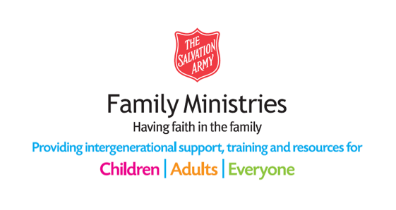

POEM

I trust in Jesus

I’ve placed my trust in Jesus Christ,
God’s son of flesh and bone.
The innocent lamb sacrificed;
I trust his word alone.

I trust he chose for man to die,
Then rose again to reign,
That as God’s seed he’d multiply
His flock when born-again.

I trust his blood can cleanse the soul;
I trust his blood can save.
His very name can make us whole
And save us from the grave.

I trust in Jesus’ loving care,
I trust he bore my shame.
I trust the love he came to share
Remains today the same.

I trust the pardon Jesus bought
Can save this wretch from hell.
I trust salvation’s true report
My Saviour had to tell.

I trust my life to Christ the Lord,
I trust in Heaven’s door.
I trust in God’s almighty sword,
I’ll trust him evermore …

Michael P Johnson

