
The Salvation Army
The Salvation Army is a Christian church and charity. We offer friendship, practical support and a welcoming community for people of all ages and backgrounds. Our faith motivates us to care for others, stand alongside people in difficult times, and share hope in practical ways.

We can offer:
- A listening ear
- A welcoming community
- Emergency parcels with a supporting referral
- Opportunity to explore and experience Christian faith
- Hope for life in all its fullness with Jesus


[Corps Name] Salvation Army
We’d love to help you find other ways to connect with our church community.
Visit [website details] or speak to a team member to find out more about our groups, events and worship services.

Welcome to [Group Name]

A parent and toddler group at [Corps Name]

Salvation Army

We’re so glad you’re here. [Group Name]
is a friendly, relaxed place for little ones to play, learn and grow, and for adults to connect, chat and feel supported.

Everyone is welcome – parents, grandparents, childminders and carers. We hope this will be a place where you and your child feel safe, valued and part of the community.

What to expect
- A friendly welcome at the door
- A sign-in point for everyone’s safety
- Free play with age-appropriate toys
- Craft or sensory activities
- Snack and drinks
- A short group time with songs, story, movement or prayer
- Time to chat and connect with others


Helping everyone feel welcome
We want [Group Name]
to be a place where every family feels they belong. If you or your child has allergies, additional needs, access needs, communication needs or would benefit from a quieter space, please speak to a team member. We will do our best to support you.

Helping everyone stay safe and happy

Children
- Please stay with and supervise your child at
all times.
- Encourage children to play kindly and safely.
- Please help children respect toys, resources
and other people.

Everyone
- Treat others with kindness and respect.
- Use positive language and behaviour.
- Be a great role model for the children.
- Help tidy up at the end of the session.
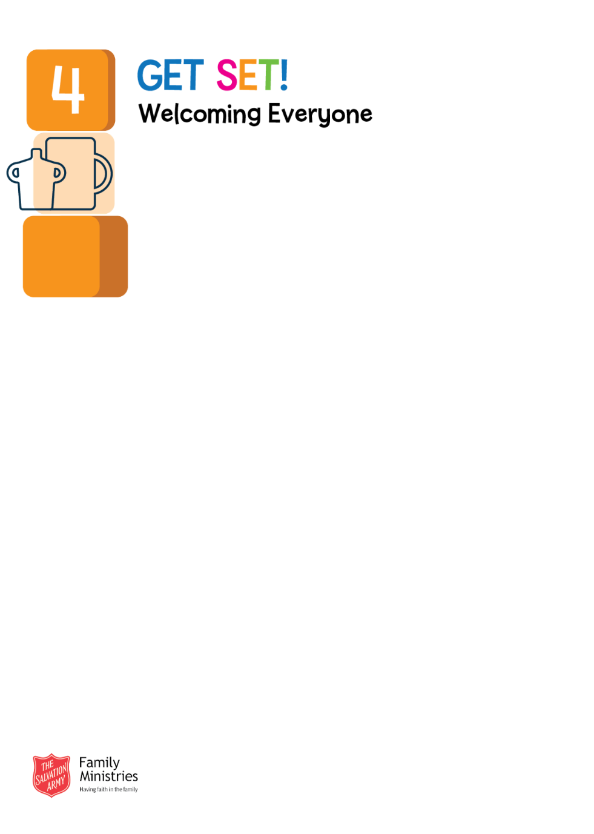
Food and allergies
- Please tell the team about any allergies or dietary needs.
- Children should sit down while eating and drinking.
- Please do not share food with other children without their parent’s or carer’s permission.

Health
- Please stay at home if you or your child are unwell.
- Please wait 48 hours after sickness or diarrhoea before returning.

Practical safety
- Keep hot drinks out of children’s reach.
- Please use the designated nappy-changing area.
- Please familiarise yourself with the fire procedures displayed at the group.

Practical information
- Day: [day]
- Time: [start time] to [finish time]
- Group leader: [name]
- Safeguarding lead: [name]. Deputy safeguarding lead: [name].
- Emergency/fire assembly point: [location]
- Cost/donation: [amount or pay-what-you-can information]
- Booking: [booking information, or first come, first served]
- Contact: [phone/email]
- Website / social media: [details]
- Accessibility information: [details]

Photos and privacy: We will not take or share photographs or videos of you or your child without consent. Please do not take photos or videos of other children without permission.

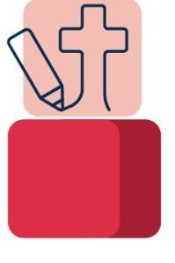
Our Christian foundation
As part of The Salvation Army, our group is rooted in Christian faith. This means you may hear simple Bible stories, songs, prayers or activities that help children and adults explore God’s love in a gentle and inclusive way. Everyone is welcome, whatever their background or belief.

Stay connected
We use WhatsApp to share reminders, updates and encouragement. Please ask the team for the QR code. To help keep everyone safe, please do not share photos, videos or personal information about other families in the group.

